DCMS System Screen Specifications
Staff Web and Patient Application
Design version 1.0 Date 05 October 2026
This document describes all 42 screens in the requirements list, grouped by feature and subfeature. Each screen includes a wireframe, a functional description mapped to use cases, processing rules, and a Field Name – Description table. The final two sections list the Background Job Inventory and External API Inventory.
The business reference is the DCMS Business Summary v1.14 dated 04 October 2026, sections 1–15 and the UC-01 to UC-37 catalog. English screen names are retained for comparison with the list; explanations and data fields are provided in English in this translation.
Payment Scope
Following the update requested on 05 October 2026, all refund operations are removed. S39 is renamed from Payment Refund and Receipt to Payment and Receipt. UC-23 Correct Payment only corrects payment recording errors, with a reason, approval, and reference to the original payment; it does not create a refund transaction or transfer money out to the Patient.
How to Read This Document
S01–S42 retain the numbering of the input list. Feature section numbers may differ from screen numbers because screens are grouped. Numbers (1), (2), … on a wireframe correspond to rows in that screen's field table. An area may represent a group of fields or a subtable; panels and modals belong to the same screen and do not create additional Screen IDs.
Wireframes illustrate layout and component positions; they are not implemented interfaces. Data shown in the images is illustrative. Business rules established in the source are retained; interface choices, data types, and limits not finalized in the source are marked [PROPOSED] or explicitly identified as requiring confirmation.
Roles and Boundaries
The Clinic Assistant handles reception, administration, payment collection, medicine dispensing, and inventory. The Dentist makes clinical decisions and manages working schedules and the service catalog. The Admin manages accounts and reads reports. The Clinic Owner inherits the Dentist role and reads reports. Guests/Patients use public functions; only a Patient with an active account and a Verified link to their own record may view their own medical records.

Design Conventions and Decisions to Finalize
Category | Applicable Convention
Time | Display dd/MM/yyyy and HH:mm in Asia/Ho_Chi_Minh; store complete timestamps and convert time zones consistently [PROPOSED]. Business thresholds: 30-minute slot units, 30/60-minute appointments, public bookings at least 60 minutes in advance, self-service changes/cancellations at least 12 hours before the appointment, and No-show 15 minutes after the appointment time.
Input Data | [PROPOSED] denotes a design proposal, not a business decision established in the source. Limits of 100/255/500/1,000/4,000 characters in the tables are proposed interface limits; the API and database must use consistent limits. Trim leading and trailing spaces; preserve Vietnamese diacritics and meaningful content.
Passwords and Verification | Passwords of 8–128 characters with passphrase support are proposed; final parameters require confirmation. The source does not define verification channels, code/token formats, expiry periods, attempt limits, or session revocation policies. A contact OTP does not verify a Patient record.
Numbers and Money | Inventory quantities are nonnegative integers in base units; dispensing/use/receipt documents require quantities > 0. Display VND amounts with thousands separators; use an exact numeric type rather than floating point [PROPOSED]. Rounding rules, maximum numeric ranges, and financial adjustment policies require confirmation.
Lists | [PROPOSED] Default to 20 rows per page, with 20/50/100 options; use server-side pagination and clearly labeled sortable columns. The All filter includes only authorized data. Lists must not retain totals beyond the permitted scope.
Interface States | Every screen supports Loading, Empty, Validation error, Server error, Access denied, and Unsaved changes where applicable [PROPOSED]. Errors must not be displayed as zero values or success. Required fields are labeled; color is always accompanied by text or a named icon.
Confirmation and Concurrency | Changes validate permissions, state, and version on the server. If a record has changed, request a refresh and preserve a recoverable draft [PROPOSED]. Booking, check-in, medicine stock issues, payment callbacks, and notifications prevent duplicate submissions using business keys; disabling interface buttons alone is insufficient.
Read Permissions and Files | Check permissions on every request, including lists, details, exports, and file URLs. A locked account or Revoked link blocks new read requests. Patients accessing their own records cannot edit medical records, view drafts/internal content, or access relatives' records.

Decisions required before implementation: weekly schedules and chair capacity; verification channels; password/session policies; file limits and types; reminder timing/counts; push and chatbot providers and image AI deployment; identity verification for access to one's own record and file publication permissions; authority to confirm financial/inventory adjustments; conversation retention policies; month/year expiry label rules; cost-of-goods methods if applicable; and Payment Gateway/PACS methods and parameters. Unconfirmed figures must not be treated as formal business constraints.

Screen Catalog and Mapping
UC codes come from section 15 of the source document. “Related” denotes navigation or data mapping; it does not rename a UC or imply an include/extend relationship. UC-19 has a staff actor preparing the bill; S42 is the Patient view of the bill and UC-20 payment.
ID | Sec. | Screen Name | Use case
S01 | 1.1.1 | Sign In | UC-01
S02 | 1.2.1 | Account Registration | UC-33
S03 | 1.3.1 | Account Recovery | UC-02
S04 | 2.1.1 | User Account Management | UC-31
S05 | 3.1.1 | Patient Search and Record | UC-08, UC-09
S06 | 3.2.1 | Patient Profile and History | UC-08, UC-09, UC-10, UC-12, UC-13, UC-14, UC-15, UC-19
S07 | 4.1.1 | Account Link Request | UC-36
S08 | 4.2.1 | Link Verification Queue | UC-36
S09 | 5.1.1 | Weekly Working Schedule | UC-03
S10 | 6.1.1 | Appointment Calendar | UC-05
S11 | 6.2.1 | Availability Search and Booking | UC-04
S12 | 6.3.1 | Appointment Detail and Exceptions | UC-05, UC-06
S13 | 7.1.1 | Mobile Home | UC-05, UC-17, UC-34
S14 | 7.2.1 | My Appointments | UC-05
S15 | 6.4.1 | Book Appointment | UC-04
S16 | 6.5.1 | Appointment Detail and Change | UC-05, UC-06
S17 | 8.1.1 | Today Reception and Waiting Queue | UC-05, UC-07, UC-24
S18 | 8.2.1 | Check In and Walk In | UC-07, UC-04, UC-08, UC-09
S19 | 9.1.1 | Clinical Visit Workspace | UC-10, UC-16, UC-12
S20 | 9.2.1 | Clinical Documents | UC-11, UC-12
S21 | 10.1.1 | Treatment Plan | UC-13
S22 | 10.2.1 | Treatment Activity | UC-14, UC-18
S23 | 11.1.1 | Prescription Editor | UC-15
S24 | 12.1.1 | Follow-up Instruction | UC-17
S25 | 12.2.1 | Follow-up Work Queue | UC-24, UC-25
S26 | 13.1.1 | Notification Center | UC-34
S27 | 13.2.1 | Notification Preferences | UC-34
S28 | 13.3.1 | Notification Failure Queue | UC-24, UC-25
S29 | 14.1.1 | Patient Chatbot | UC-35, UC-04, UC-06
S30 | 14.2.1 | Staff Support Inbox | UC-26
S31 | 15.1.1 | Service Catalog and Editor | UC-30
S32 | 16.1.1 | Medicine Catalog and Editor | UC-27; updating is a business function in MD-18
S33 | 17.1.1 | Stock and Batch Overview | Related to UC-27; no separate UC for stock overview
S34 | 17.2.1 | Medicine Receipt | UC-28
S35 | 17.3.1 | Stock Count and Adjustment | UC-29
S36 | 17.4.1 | Quality Issue and Batch Disposition | MD-12–MD-15 functions; related to UC-27, UC-29, UC-25; no separate UC
S37 | 18.1.1 | Medicine Dispensing Treatment Use and Return | UC-22, UC-18; returns received under MD-14
S38 | 19.1.1 | Patient Bill | UC-19
S39 | 20.1.1 | Payment and Receipt | UC-20, UC-21, UC-23
S40 | 21.1.1 | Reports Dashboard and Viewer | UC-32
S41 | 7.3.1 | My Medical Records | UC-37
S42 | 7.4.1 | My Invoices and Payments | UC-19, UC-20

UC-16 Analyze X-ray with AI is specified in the AI tab of S19, without adding a Screen ID beyond the 42-screen list. UC-01 includes sign-out in the account menu. Detailed inventory functions in S32, S33, S36, and S37 are based on MD-01–MD-18; the 37-UC catalog does not contain separate ovals for all these functions.

1 User Authentication

1.1 Account Access

1.1.1 Sign In
Screen ID S01 | Staff web / shared access
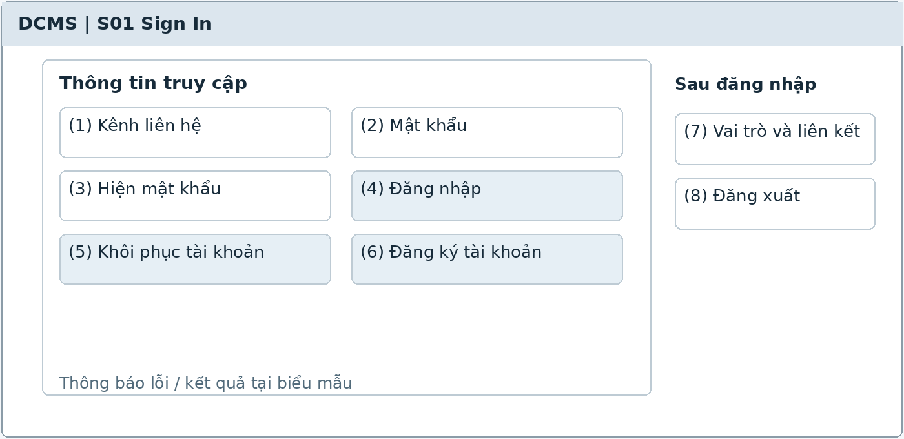
Illustrative UI layout Numbers in the image correspond to the field table on the next page
Functional Description and Use Cases
Allows account holders to sign in and access authorized functions. Menus, data, and direct links are all subject to permission checks; signing in does not automatically grant the Patient role or access to medical records.
Roles: Registered User and other roles with accounts.
Rules and Outcomes
• Successful sign-in redirects according to the role and record link status.
• Incorrect credentials display a generic error; a locked account cannot create an access session.
• Sign-out ends the session on the current device; unsaved changes require a warning.

Field Description S01
Sign In | 1.1.1
Field Name | Description
Sign-in Information
(1) Contact channel | String; required. Verified email address or phone number, depending on the implemented channel; initially blank. Normalize whitespace and format before submission.
(2) Password | Secret string; required; initially blank with masked characters. Apply the password policy in Design Conventions; do not log the value.
(3) Show password | Boolean; off by default. Changes only the display on the device, not the entered data.
(4) Sign in | Button; enabled when sufficient valid data is provided. Show processing and prevent duplicate submissions; display errors in the form.
(5) Recover account | Link to S03; retain the entered contact channel if the user agrees to continue.
(6) Register account | Link to S02; public registration creates only a Guest account.
Access Session
(7) Roles and link | Read-only; retrieved from the server after authentication. If multiple roles exist, show the corresponding functions; only Verified grants access to the user's own records.
(8) Sign out | Button in the account menu after sign-in. Revoke the current session and return to the public screen; do not delete patient records.

The common conventions for permissions, input data, error states, pagination, and concurrent operations also apply. [PROPOSED] identifies a limit or design choice requiring confirmation; it does not replace business rules in the source.

1.2 Account Registration

1.2.1 Account Registration
Screen ID S02 | Staff web / shared access
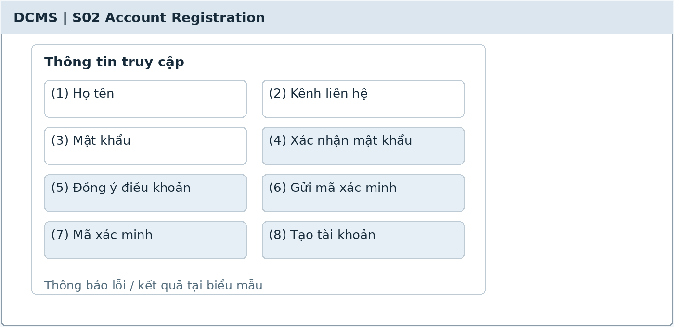
Illustrative UI layout Numbers in the image correspond to the field table on the next page
Functional Description and Use Cases
A Guest creates a public account through a verified contact channel. The screen includes information entry, contact verification, and the registration result; it does not create a Patient record.
Roles: Guest.
Mapping: UC-33. References: MB-01, MB-02.
Rules and Outcomes
• Do not offer staff role selection in the public form.
• An existing contact channel directs the user to sign in or recover access; do not create duplicate accounts.
• Public permissions take effect after registration; record linking is requested separately in S07.

Field Description S02
Account Registration | 1.2.1
Field Name | Description
Account Information
(1) Full name | String of 1–100 characters [PROPOSED]; required; initially blank. The account name is not evidence of Patient identity.
(2) Contact channel | Email address or phone number; required; normalized. Must be unique under the account policy; Patient records may still share a phone number.
(3) Password | String of 8–128 characters [PROPOSED]; required; masked. Validate against the common policy; do not store plaintext.
(4) Confirm password | String; required; initially blank; must match the password and is not stored as a separate field.
(5) Agree to terms | Boolean [PROPOSED]; unchecked by default. Display links to the applicable terms and data policy.
Contact Verification
(6) Send verification code | Button that sends through the selected channel; expiry and send limits follow configuration requiring confirmation. Display when resending becomes available.
(7) Verification code | String in the provider's format; required at the verification step. Check expiry, prior use, and attempt counts on the server.
(8) Create account | Button that operates only after successful verification; one submission must not create multiple accounts. The result opens S01 or a public session according to configuration.

The common conventions for permissions, input data, error states, pagination, and concurrent operations also apply. [PROPOSED] identifies a limit or design choice requiring confirmation; it does not replace business rules in the source.

1.3 Account Recovery

1.3.1 Account Recovery
Screen ID S03 | Staff web / shared access
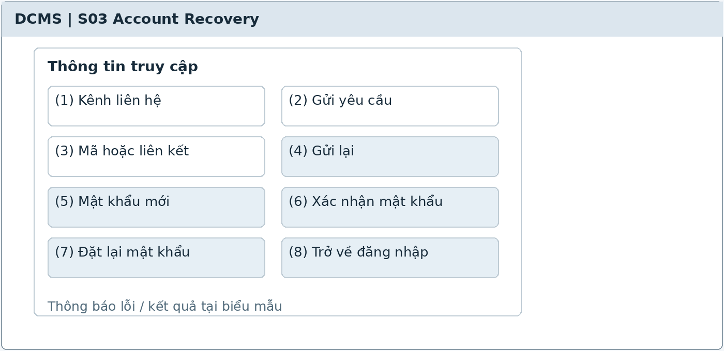
Illustrative UI layout Numbers in the image correspond to the field table on the next page
Functional Description and Use Cases
Recovers access through a verified contact channel, then sets a new password. Do not use this process to verify a record link.
Roles: Registered User.
Mapping: UC-02. References: MB-07.
Rules and Outcomes
• Recovery requests receive a generic response to limit account disclosure.
• Codes that have expired, been used, or exceeded the configured attempt limit are rejected.
• Locked accounts require Admin intervention; password reset does not automatically unlock them.

Field Description S03
Account Recovery | 1.3.1
Field Name | Description
Recovery Request
(1) Contact channel | Verified email address or phone number; required; initially blank; normalized as in S01.
(2) Send request | Button; show sending and a generic result. Rate limits follow configuration [PROPOSED].
(3) Code or link | Single-use recovery proof with an expiry. Do not display or log tokens; the format follows the implementation approach.
(4) Resend | Button; enabled only after the waiting period. Does not increase access permissions or bypass attempt limits.
New Password
(5) New password | String of 8–128 characters [PROPOSED]; required and masked; follows the same policy as S02.
(6) Confirm password | String; required; must match the new password; not stored separately.
(7) Reset password | Button; enabled only while the proof remains valid. Audit the event and revoke old sessions according to the session policy [PROPOSED].
(8) Return to sign-in | Link to S01 after success; account lock checks remain in effect.

The common conventions for permissions, input data, error states, pagination, and concurrent operations also apply. [PROPOSED] identifies a limit or design choice requiring confirmation; it does not replace business rules in the source.

2 User Administration

2.1 Account Management

2.1.1 User Account Management
Screen ID S04 | Staff web
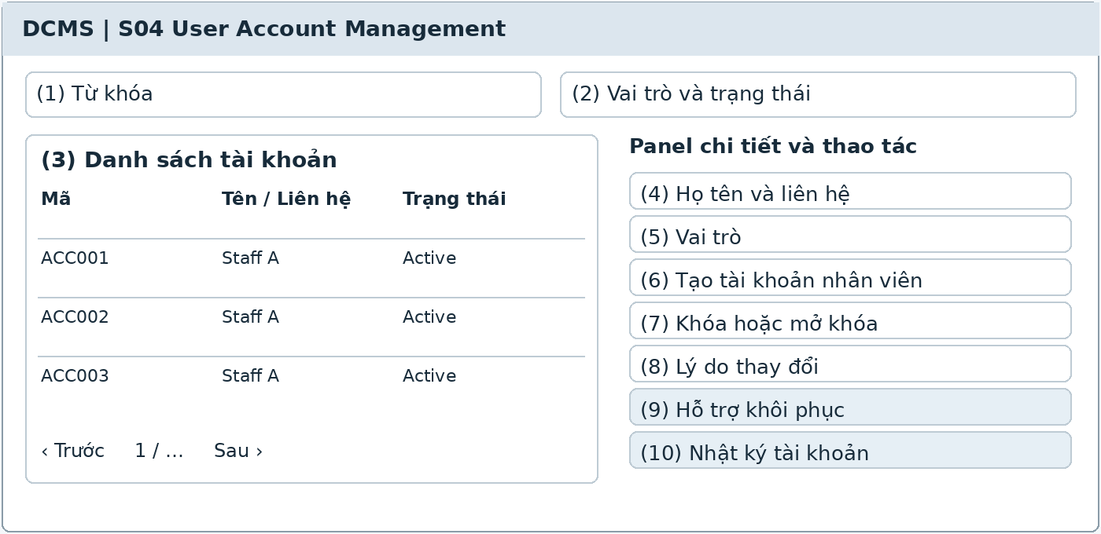
Illustrative UI layout Numbers in the image correspond to the field table on the next page
Functional Description and Use Cases
The Admin searches accounts, creates staff accounts, assigns or revokes roles, and locks or unlocks accounts. Account details open in a panel; all significant changes are audited.
Roles: Admin.
Mapping: UC-31. References: MB-07, section 9, section 15.
Rules and Outcomes
• Dentists and Clinic Owners do not automatically have account management permissions.
• Account management must not be used to edit medical records or verify Patient links.
• Locking an account blocks subsequent access and private deliveries; clinical data is retained.

Field Description S04
User Account Management | 2.1.1
Field Name | Description
Search and List
(1) Keyword | String of 0–100 characters [PROPOSED]; initially blank; search by code, name, or contact channel, only among accounts the user may manage.
(2) Role and status | Filters; All by default. Minimum statuses are Active or Locked; roles come from the current permission catalog.
(3) Account list | Table of code, full name, contact details, roles, status, and last update; column sorting and pagination follow the common conventions.
Details and Actions
(4) Full name and contact | Strings as in S02; required when creating staff accounts. Check duplicate contacts; do not automatically create a Patient.
(5) Roles | Multi-select from staff roles that may be assigned. Do not infer inventory permissions from report permissions; validate permissions on the server.
(6) Create staff account | Button that opens the creation panel; sends an invitation or sets up access using the selected approach; does not display old passwords.
(7) Lock or unlock | Button that changes according to the current status; confirm before saving. Does not delete the account or related records.
(8) Reason for change | String of 1–500 characters [PROPOSED]; required for locking, unlocking, or changing permissions; record the actor and timestamp.
(9) Recovery support | Button that initiates the authorized recovery process; does not replace Patient account link verification.
(10) Account audit log | Read-only; actor, time, change type, and reason; contains no passwords or tokens.

The common conventions for permissions, input data, error states, pagination, and concurrent operations also apply. [PROPOSED] identifies a limit or design choice requiring confirmation; it does not replace business rules in the source.

3 Patient Records

3.1 Patient Administration

3.1.1 Patient Search and Record
Screen ID S05 | Staff web
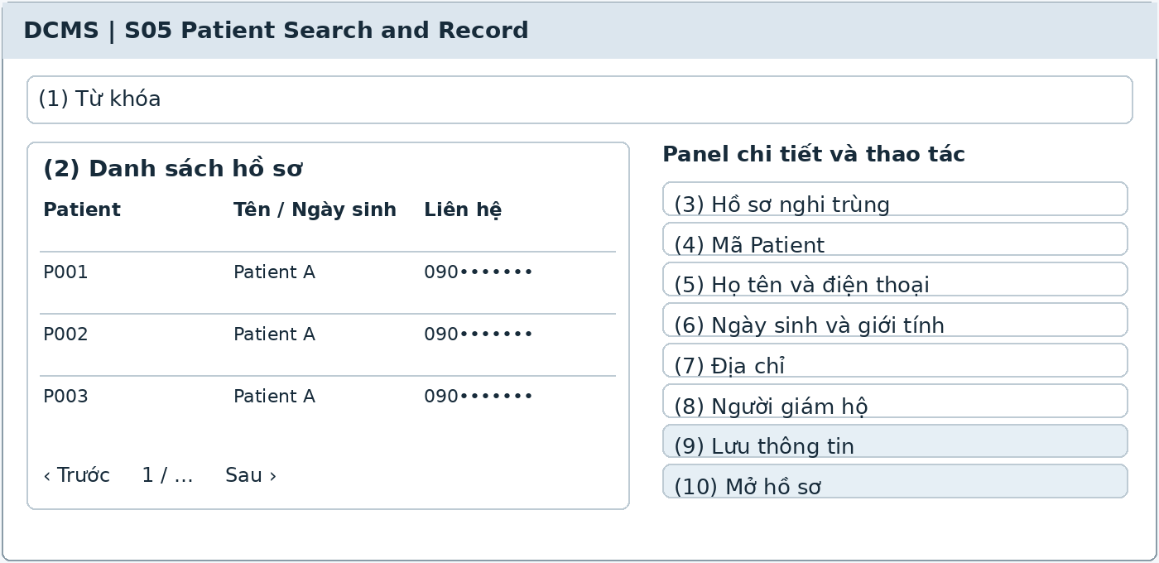
Illustrative UI layout Numbers in the image correspond to the field table on the next page
Functional Description and Use Cases
Search records by code, name, or phone number; update administrative details and view potential duplicate warnings. New records are created only after verifying the person attending at check-in in S18.
Roles: Clinic Assistant; Dentist reads authorized data.
Mapping: UC-08, UC-09. References: PT-01–PT-05, PT-09–PT-11.
Rules and Outcomes
• Phone numbers are not unique in Patient records; do not use them for automatic merging.
• Potential duplicate warnings require review and do not provide automatic merging.
• The Clinic Assistant edits only administrative data; clinical content is handled through the dentist's screens.

Field Description S05
Patient Search and Record | 3.1.1
Field Name | Description
Lookup
(1) Keyword | String of 0–100 characters [PROPOSED]; initially blank; search by Patient code, full name, or phone number; do not enforce unique phone numbers.
(2) Record list | Table of Patient code, name, date of birth if available, phone number, and last visit. Return only data within the authorized scope.
(3) Potential duplicate records | Suggested records for comparison [PROPOSED]; show supporting details such as name, date of birth, or contact; do not automatically conclude they represent the same person.
Administrative Information
(4) Patient code | System-generated code, read-only; created at the actual patient's first check-in.
(5) Full name and phone number | Full name of 1–100 characters; contact of up to 20 characters [PROPOSED]; required under PT-02; shared contact details are allowed.
(6) Date of birth and gender | Date must not be in the future [PROPOSED]; gender follows the finalized catalog; optional, with no information by default.
(7) Address | String of 0–255 characters [PROPOSED]; optional; does not replace primary identity information.
(8) Guardian | Name, relationship, and contact; required when a need for representation is identified; does not grant medical record access through the app.
(9) Save information | Button; check edit permissions and the latest version; audit administrative changes with the actor and timestamp.
(10) Open record | Button that opens S06 for the selected row; creating a new Patient leads to the S18 process, rather than creating one directly from search.

The common conventions for permissions, input data, error states, pagination, and concurrent operations also apply. [PROPOSED] identifies a limit or design choice requiring confirmation; it does not replace business rules in the source.

3.2 Patient History

3.2.1 Patient Profile and History
Screen ID S06 | Staff web
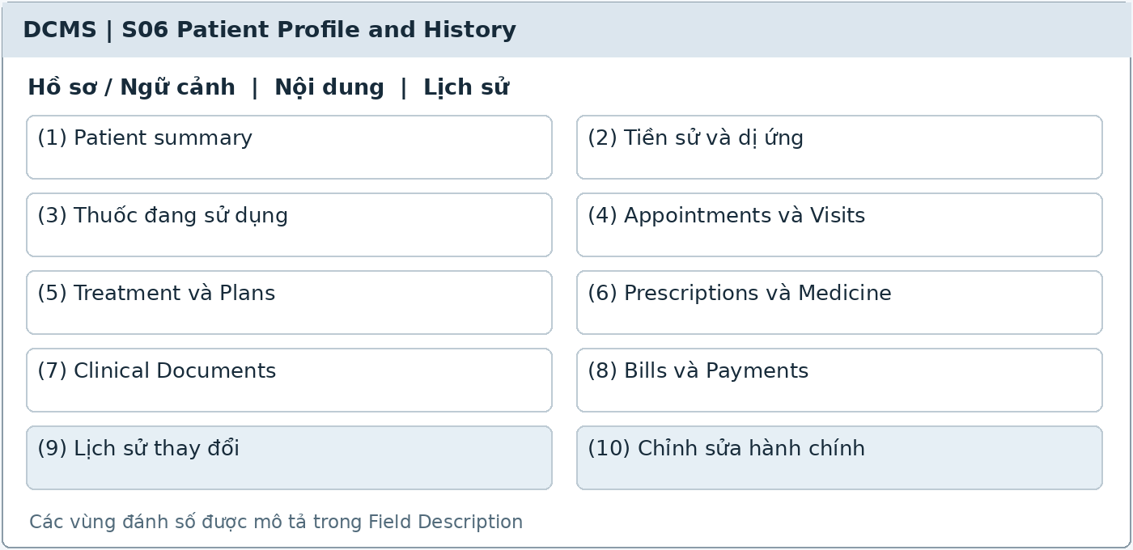
Illustrative UI layout Numbers in the image correspond to the field table on the next page
Functional Description and Use Cases
The record hub displays administrative details and tabs for visits, treatment, prescriptions, documents, medicines actually dispensed or used, and finances according to permissions. This is the staff interface; Patients view their own records in S41.
Roles: Clinic Assistant; Dentist within scope; Clinic Owner inherits Dentist.
Mapping: UC-08, UC-09, UC-10, UC-12, UC-13, UC-14, UC-15, UC-19. References: PT-06–PT-11, MR-01–MR-08.
Rules and Outcomes
• Each tab and document checks permissions independently; read access does not automatically grant edit access.
• Distinguish None from Unknown in medical history; only the dentist confirms clinical content.
• History retains the actor, time, and version; concurrent updates require loading the latest version.

Field Description S06
Patient Profile and History | 3.2.1
Field Name | Description
Identity and Health
(1) Patient summary | Code, full name, date of birth, contact, and guardian if applicable; read-only from the selected record and always displayed at the top of the page.
(2) Medical history and allergies | Data group with Unknown, None, or Information available states; content up to 4,000 characters [PROPOSED]; updated by the dentist.
(3) Current medications | Health declaration list; not counted as medicine issued from inventory; includes the latest confirmation time.
History Tabs
(4) Appointments and Visits | Lists appointments and visits by date, dentist, and status; opens S12 or S19 according to permissions.
(5) Treatment and Plans | Lists plans, patient decisions, agreed prices, and performed services; opens S21 or S22.
(6) Prescriptions and Medicine | Completed prescriptions and dispensing/use events by batch; show prescribed and actually dispensed quantities separately; opens S23 or S37.
(7) Clinical Documents | Files by Patient, visit, or plan; a URL alone does not grant file access; opens S20.
(8) Bills and Payments | Bills, collected payments, allocated deposits, and outstanding balances; shown only to authorized staff; opens S38 or S39.
(9) Change history | Records of actor, time, before/after content, and reason where required; read-only, with no audit log deletion.
(10) Edit administrative details | Button that opens S05 updates; clinical conclusions, prescriptions, and agreed prices cannot be edited from the administrative tab.

The common conventions for permissions, input data, error states, pagination, and concurrent operations also apply. [PROPOSED] identifies a limit or design choice requiring confirmation; it does not replace business rules in the source.

4 Account Linking

4.1 Self Record Linking

4.1.1 Account Link Request
Screen ID S07 | Patient app / public web
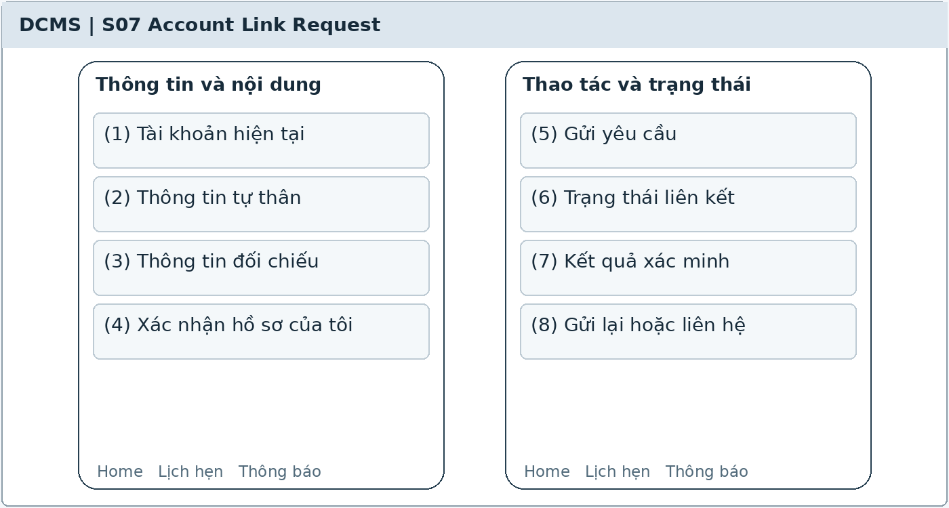
Illustrative UI layout Numbers in the image correspond to the field table on the next page
Functional Description and Use Cases
A Patient requests verification of a link between their account and their own record. Contact verification is only an account prerequisite; medical record access is granted after the Clinic Assistant verifies the record.
Roles: Patient with an active account.
Mapping: UC-36. References: MB-02, MB-03, MR-01, section 13.6.
Rules and Outcomes
• At most one active self-record link per account and per Patient.
• Do not automatically link based on a shared phone number, booking for someone else, or knowledge of a Patient code alone.
• Pending, Rejected, and Revoked do not grant medical record access; Verified grants access within scope.

Field Description S07
Account Link Request | 4.1.1
Field Name | Description
Link Request
(1) Current account | Read-only; account code and verified contact; do not accept an arbitrary AccountId from the user.
(2) Personal identity details | Name, date of birth if available, and Patient code if known; name is required, other fields depend on the verification approach. Do not expose a full Patient search to the app.
(3) Matching information | Visit information or evidence under the clinic's process; 0–1,000 characters [PROPOSED]; avoid collecting unnecessary data.
(4) Confirm this is my record | Boolean [PROPOSED]; unchecked by default; booking for a relative does not qualify for a self-record link request.
(5) Send request | Button; check for an existing link or a request being processed. Creates Pending without granting immediate read access.
Request Status
(6) Link status | Read-only; Pending, Verified, Rejected, or Revoked; initially Not linked.
(7) Verification result | Show the time and reasons that may be disclosed; do not expose another Patient's information or internal notes.
(8) Resubmit or contact | After rejection or revocation, open support or create a new request under the process; do not automatically change to Verified.

The common conventions for permissions, input data, error states, pagination, and concurrent operations also apply. [PROPOSED] identifies a limit or design choice requiring confirmation; it does not replace business rules in the source.

4.2 Link Review

4.2.1 Link Verification Queue
Screen ID S08 | Staff web
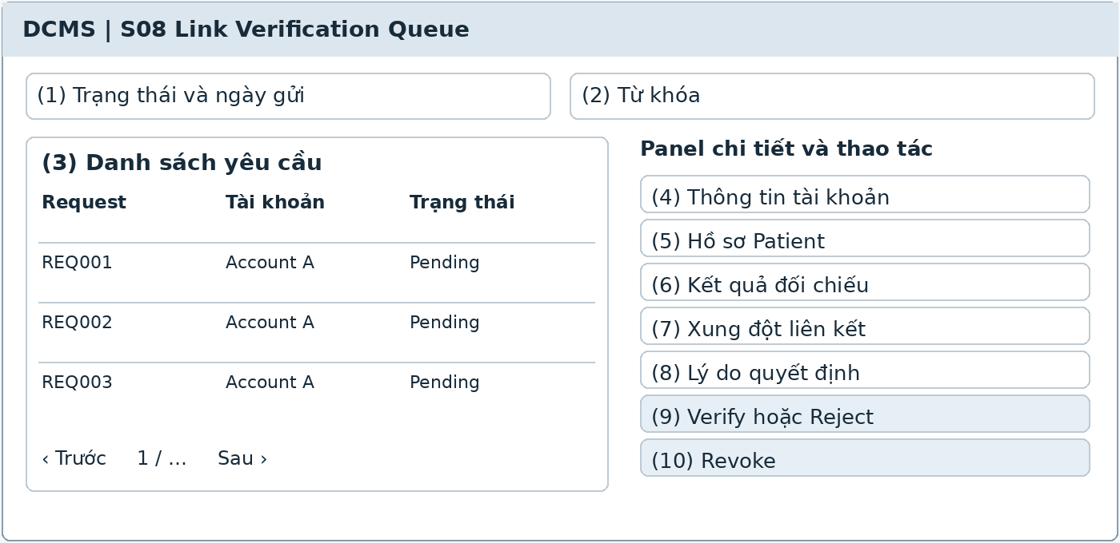
Illustrative UI layout Numbers in the image correspond to the field table on the next page
Functional Description and Use Cases
A queue for assistants to compare identities and verify, reject, or revoke links to patients' own records. The panel places the account and proposed record side by side and retains an audit trail of decisions.
Roles: Authorized Clinic Assistant.
Mapping: UC-36. References: MB-02, MB-03, MB-07, MR-07.
Rules and Outcomes
• Revalidate the one-to-one constraint before saving; do not rely solely on a phone number.
• Rejection or revocation requires a reason; clinical records are not deleted.
• Revocation blocks subsequent reads and cancels private notifications not yet sent.

Field Description S08
Link Verification Queue | 4.2.1
Field Name | Description
Queue
(1) Status and submission date | Filter by Pending, Verified, Rejected, Revoked, or All; default Pending; valid date range.
(2) Keyword | String of 0–100 characters [PROPOSED]; search accounts or requests within the processing scope.
(3) Request list | Request code, account, time, status, and handler; click a row to open the comparison panel.
Comparison and Decision
(4) Account information | Read-only; verified contact and self-declared information; not the sole evidence.
(5) Patient record | Permission-limited lookup; select the requester's own Patient record and show its code and identifying details for checking.
(6) Comparison result | String of 1–1,000 characters [PROPOSED]; record the verification method or evidence, reviewer, and timestamp.
(7) Link conflict | Read-only; warn if the account or Patient already has an active link; block duplicate verification.
(8) Decision reason | String of 1–500 characters [PROPOSED]; required for rejection or revocation; distinguish internal notes from notification content.
(9) Verify or Reject | Buttons for a Pending request; confirm the correct record before saving; recheck the latest status.
(10) Revoke | Button for Verified; requires confirmation and a reason; changes to Revoked and retains decision history.

The common conventions for permissions, input data, error states, pagination, and concurrent operations also apply. [PROPOSED] identifies a limit or design choice requiring confirmation; it does not replace business rules in the source.

5 Working Schedule

5.1 Weekly Availability

5.1.1 Weekly Working Schedule
Screen ID S09 | Staff web
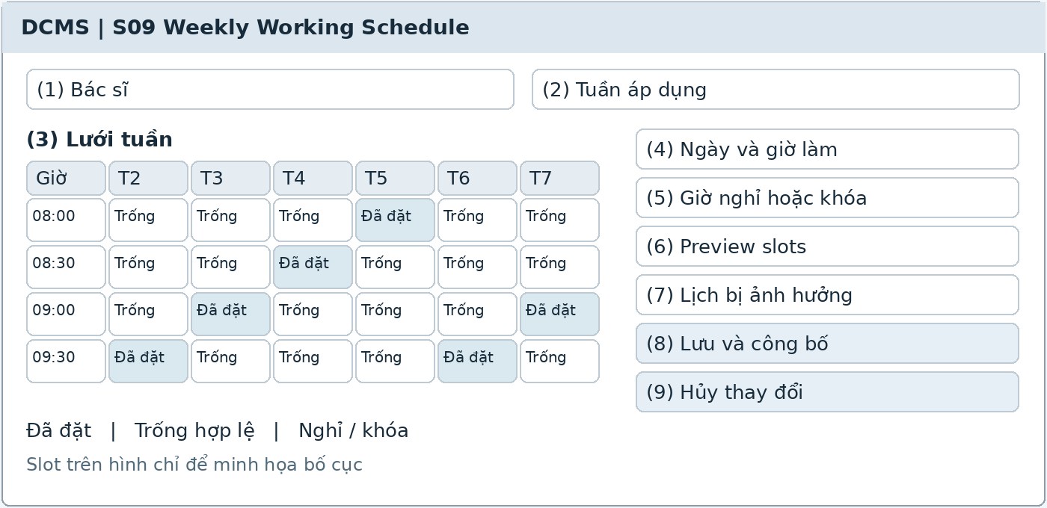
Illustrative UI layout Numbers in the image correspond to the field table on the next page
Functional Description and Use Cases
The Dentist manages weekly working periods and breaks, previews 30- or 60-minute slots, and publishes a valid week. An affected-appointments panel supports resolution before working hours are reduced.
Roles: Dentist; Clinic Owner inherits Dentist.
Mapping: UC-03. References: AP-03, AP-11, BR-01–BR-08.
Rules and Outcomes
• Periods on the same day must not overlap; slots must fit entirely within working hours and must not cross breaks or blocked periods.
• Do not change or remove working periods in a way that invalidates confirmed appointments.
• Staff attendance and leave are not managed here; chair capacity is still checked during booking.

Field Description S09
Weekly Working Schedule | 5.1.1
Field Name | Description
Week Scope
(1) Dentist | Dentist code from the session; defaults to self; another dentist's schedule cannot be edited without explicit permission.
(2) Applicable week | Week start date and a seven-day range; defaults to the current week; the calendar displays clinic local time.
(3) Weekly grid | Seven days with working periods, breaks, and blocks; includes a legend; dragging and panel editing use the same validation.
Time Periods
(4) Working day and hours | Day within the applicable week; start time must precede end time; multiple nonoverlapping periods per day.
(5) Breaks or blocks | List of periods within the corresponding day, excluded from slots; block reasons up to 500 characters [PROPOSED].
(6) Preview slots | Select 30- or 60-minute previews; read-only. A 60-minute appointment requires two consecutive units with the same dentist.
(7) Affected appointments | Table of appointment code, time, attendee, and status; block publication while any appointment remains invalidated; direct staff to S12 for resolution.
(8) Save and publish | Button that validates the entire week and latest version. Publish only when valid; record the actor and time.
(9) Discard changes | Button that discards unsaved changes; does not cancel booked appointments or a published week.

The common conventions for permissions, input data, error states, pagination, and concurrent operations also apply. [PROPOSED] identifies a limit or design choice requiring confirmation; it does not replace business rules in the source.

6 Appointment Management

6.1 Staff Calendar

6.1.1 Appointment Calendar
Screen ID S10 | Staff web
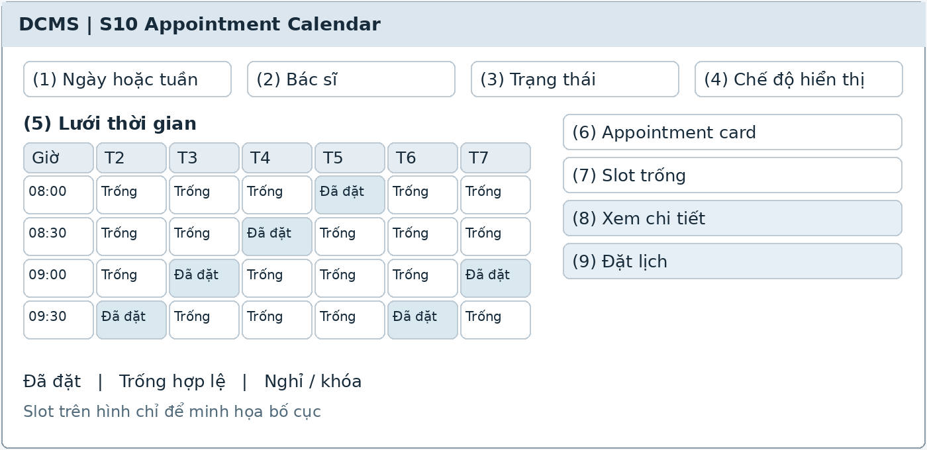
Illustrative UI layout Numbers in the image correspond to the field table on the next page
Functional Description and Use Cases
Displays appointments by day or week, dentist, and status, together with eligible available periods. Dentists view their own schedules; booking and exception handling belong to the Clinic Assistant.
Roles: Clinic Assistant; Dentist reads authorized schedules.
Mapping: UC-05. References: AP-08, AP-13, AP-15, BR-08.
Rules and Outcomes
• The legend distinguishes statuses using both text and color.
• Displayed slots reflect availability at load time; confirmation must recheck it.
• Visit completion and payment are independent; Completed does not imply paid.

Field Description S10
Appointment Calendar | 6.1.1
Field Name | Description
Calendar Navigation
(1) Day or week | Selector; defaults to today in Asia/Ho_Chi_Minh; Previous, Next, and Today buttons.
(2) Dentist | Filter listing dentists whose schedules may be viewed; defaults to self for Dentist; filters do not expand permissions.
(3) Status | All, Confirmed, Checked-in, Completed, Cancelled, No-show; defaults to appointments currently relevant to the selected date [PROPOSED].
(4) Display mode | Day or Week; defaults to Day [PROPOSED]; retain the choice during the session.
Calendar and Actions
(5) Time grid | 30-minute units; show working hours, breaks, and occupied periods; a 60-minute appointment occupies two consecutive units.
(6) Appointment card | Code, time, attendee, source, and status according to permissions; do not show diagnoses on shared calendar cards.
(7) Available slot | Bookable periods according to duration, dentist, and chair; click to open S11 with prefilled selections.
(8) View details | Click an appointment to open S12; Dentists only receive actions allowed by their permissions.
(9) Book appointment | Clinic Assistant button that opens S11; refresh the grid after success; do not create an approval-pending status.

The common conventions for permissions, input data, error states, pagination, and concurrent operations also apply. [PROPOSED] identifies a limit or design choice requiring confirmation; it does not replace business rules in the source.

6.2 Staff Booking

6.2.1 Availability Search and Booking
Screen ID S11 | Staff web
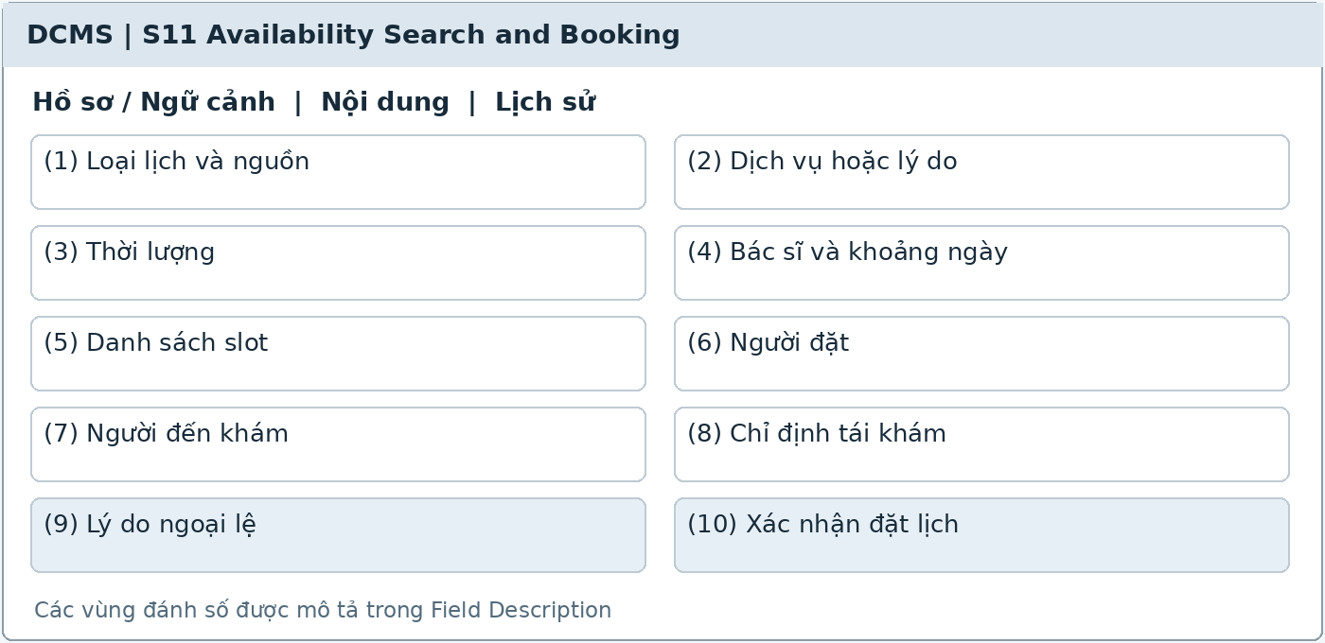
Illustrative UI layout Numbers in the image correspond to the field table on the next page
Functional Description and Use Cases
The assistant searches slots and books standard, walk-in, or follow-up appointments. Store the booker and attendee separately; create Confirmed immediately when all checks pass.
Roles: Clinic Assistant.
Mapping: UC-04. References: AP-01–AP-04, AP-06, AP-09, AP-12–AP-15, FU-02.
Rules and Outcomes
• Walk-ins still require a Confirmed available period; booking another date does not create a current visit or queue entry.
• Staff may book less than 60 minutes in advance with a reason, without bypassing conflict checks.
• If a slot has become occupied, require reselection; booking alone does not create a Patient.

Field Description S11
Availability Search and Booking | 6.2.1
Field Name | Description
Availability Criteria
(1) Appointment type and source | Standard, Walk-in, or Follow-up [PROPOSED]; source: phone, Zalo, Facebook, in person, or app; record the source only, without automatically integrating these channels.
(2) Service or reason | Select from the active catalog; Examination and consultation defaults to 30 minutes; free-text reason up to 1,000 characters [PROPOSED].
(3) Duration | Read-only, 30 or 60 minutes according to service configuration or instruction; no arbitrary entry.
(4) Dentist and date range | Select a specific dentist or search by time; do not suggest slots outside working hours, during breaks, or exceeding chair capacity.
(5) Slot list | Start time, end time, dentist, and duration; select exactly one slot; recheck on confirmation.
Booker and Attendee
(6) Booker | Full name of 1–100 characters and valid contact [PROPOSED]; required; separate from the attendee and PatientId.
(7) Patient attending | Full name required; minimum identity details under the process, date of birth if available; Self or Relative; PatientId optional if the correct person has been identified.
(8) Follow-up instruction | Select a valid instruction for the correct Patient when the type is Follow-up; at most one active appointment per instruction.
(9) Exception reason | String of 1–500 characters [PROPOSED]; required when staff book closer to the appointment than the public limit permits.
(10) Confirm booking | Button; summarize attendee, dentist, and time. Success returns a Confirmed code; resubmitting the same operation does not create a second appointment.

The common conventions for permissions, input data, error states, pagination, and concurrent operations also apply. [PROPOSED] identifies a limit or design choice requiring confirmation; it does not replace business rules in the source.

6.3 Staff Exceptions

6.3.1 Appointment Detail and Exceptions
Screen ID S12 | Staff web
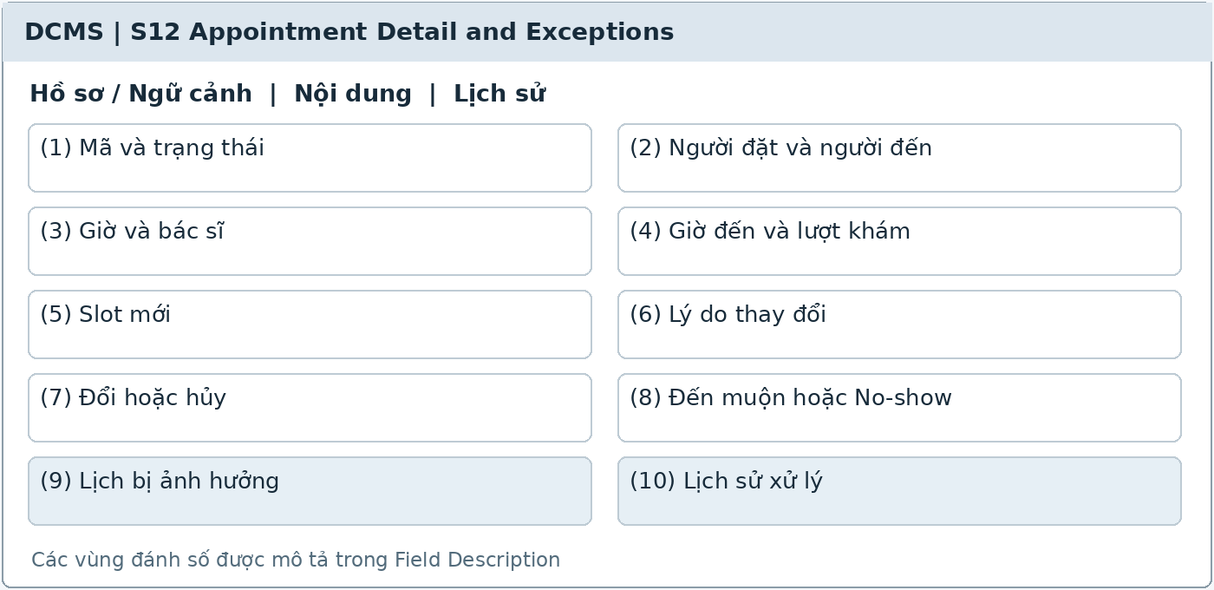
Illustrative UI layout Numbers in the image correspond to the field table on the next page
Functional Description and Use Cases
Appointment detail screen for viewing history, rescheduling/cancelling, handling working-hour changes, and late arrivals. Exception panels retain reasons and link support requests or replacement appointments.
Roles: Clinic Assistant; Dentist views authorized schedules.
Mapping: UC-05, UC-06. References: AP-05, AP-10–AP-11, AP-16–AP-19.
Rules and Outcomes
• Release the old time only after successful rescheduling; errors leave the appointment unchanged.
• No-show must not automatically reopen an elapsed slot; new reception requires sufficient valid available time.
• Clinical priority outside queue order requires a dentist's decision; do not automatically change dentists.

Field Description S12
Appointment Detail and Exceptions | 6.3.1
Field Name | Description
Appointment Details
(1) Code and status | Read-only; Appointment code and Confirmed, Checked-in, Completed, Cancelled, or No-show; no Pending confirmation status.
(2) Booker and attendee | Two separate groups; PatientId exists only when the correct person is identified; contact details follow support permissions.
(3) Time and dentist | Start, end, duration of 30 or 60 minutes, dentist, and source; change only through valid actions.
(4) Arrival time and visit | Read-only after check-in; linked Visit; do not create visits by directly editing fields.
Exceptions and Changes
(5) New slot | Selection panel as in S11; used only for eligible rescheduling. Validate atomically against the current appointment and latest version.
(6) Reason for change | String of 1–500 characters [PROPOSED]; required for rescheduling, cancellation, or disruption handling; record the actor and time.
(7) Reschedule or cancel | Buttons according to status and permissions; process immediately when valid. Block actions on started or checked-in appointments unless a separate process exists.
(8) Late arrival or No-show | Show reception eligibility and callback results; rebooking creates a new record linked to the original No-show appointment.
(9) Affected appointments | When a dentist reduces working hours, show the proposed change; staff contact patients and resolve appointments before updating working hours.
(10) Processing history | List of appointment versions, reasons, actors, times, and notifications; do not delete old appointments or overwrite No-show records.

The common conventions for permissions, input data, error states, pagination, and concurrent operations also apply. [PROPOSED] identifies a limit or design choice requiring confirmation; it does not replace business rules in the source.

6.4 Public Booking

6.4.1 Book Appointment
Screen ID S15 | Patient app / public web
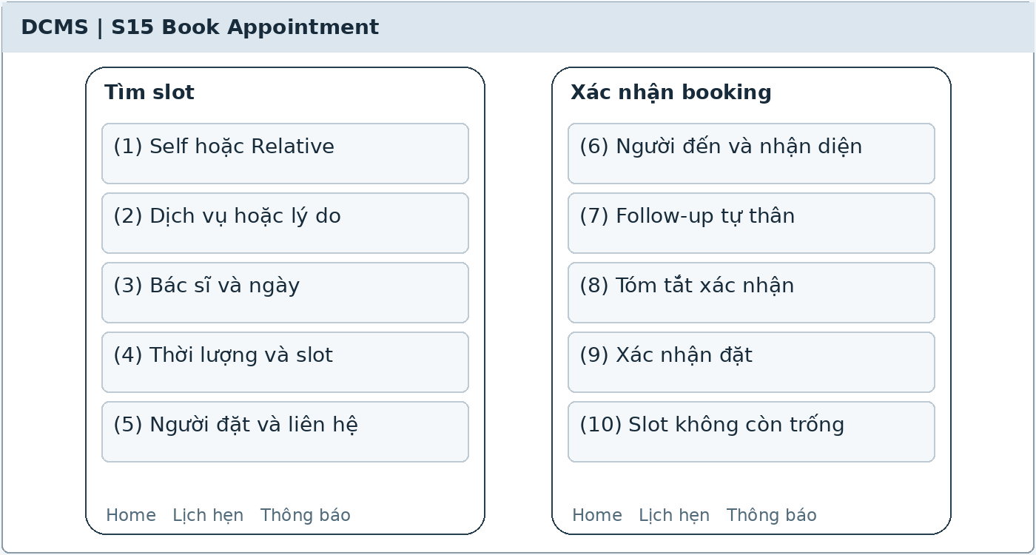
Illustrative UI layout Numbers in the image correspond to the field table on the next page
Functional Description and Use Cases
A public form allows booking for oneself or a relative without an account. Select a 30- or 60-minute slot according to reason/service, review the summary, and confirm.
Roles: Guest or Patient.
Mapping: UC-04. References: AP-01, AP-04, AP-06, AP-13–AP-15, MB-05, FU-02.
Rules and Outcomes
• Book at least 60 minutes in advance; Guests do not have staff exception permissions.
• Booker information is separate from the attendee; do not create a Patient or automatic link.
• The slot must remain available when saved; report success only from the result returned by DCMS.

Field Description S15
Book Appointment | 6.4.1
Field Name | Description
Find a Slot
(1) Self or Relative | Required choice; defaults to Self [PROPOSED]; Relative opens a separate attendee group and does not grant access to their medical records.
(2) Service or reason | Select from the public catalog; defaults to Examination and consultation, 30 minutes; additional text up to 1,000 characters [PROPOSED].
(3) Dentist and date | Select a dentist or time range; show public data without displaying other bookers' names.
(4) Duration and slot | 30 or 60 minutes from configuration; select only valid periods with sufficient duration at least 60 minutes in advance.
Booking Information
(5) Booker and contact | Name of 1–100 characters and a valid contact channel [PROPOSED]; required; prefill from the account if available and allow review.
(6) Attendee and identity | Name required; date of birth or minimum information under the process; do not require PatientId for a first-time patient.
(7) Own follow-up | Optional when Verified and the instruction remains valid; retain the required duration and dentist; do not accept a relative's instruction.
(8) Confirmation summary | Attendee, dentist, time, duration, and contact; read-only from current selections; the user confirms before submission.
(9) Confirm booking | Button; block duplicate submission. Success displays a Confirmed code; do not create a status awaiting staff approval.
(10) Slot no longer available | Business notification; retain user-entered data and request reselection; do not create a failed booking.

The common conventions for permissions, input data, error states, pagination, and concurrent operations also apply. [PROPOSED] identifies a limit or design choice requiring confirmation; it does not replace business rules in the source.

6.5 Public Appointment Changes

6.5.1 Appointment Detail and Change
Screen ID S16 | Patient app / public web
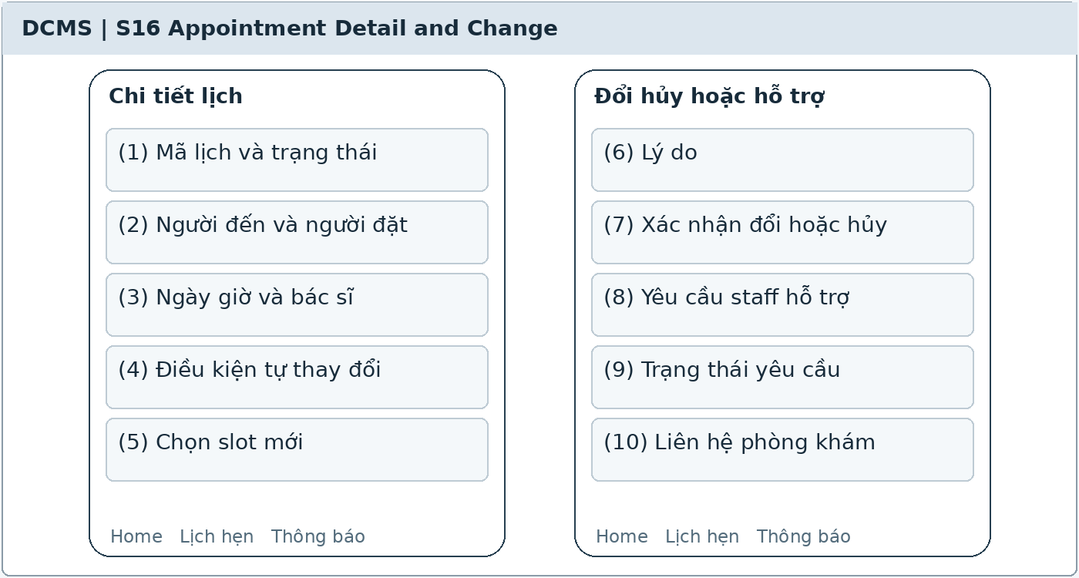
Illustrative UI layout Numbers in the image correspond to the field table on the next page
Functional Description and Use Cases
Displays authorized booking details, allows self-service rescheduling/cancellation within the deadline, or submits a staff support request. A support request is a separate record; the original appointment remains active until successfully handled.
Roles: Account owning the booking or Patient with a Verified link to their own record.
Mapping: UC-05, UC-06. References: AP-05, AP-19, MB-04, MB-06, section 13.6.
Rules and Outcomes
• Only Confirmed appointments that have not started and are at least 12 hours away may be changed/cancelled through self-service; exactly 12 hours is still valid.
• The new slot must meet the 60-minute advance-booking requirement and all availability checks.
• Guests without accounts contact staff using the appointment code and verified channel.

Field Description S16
Appointment Detail and Change | 6.5.1
Field Name | Description
Booking detail
(1) Appointment code and status | Read-only; minimum data according to permissions; do not allow PatientId changes to access another appointment.
(2) Attendee and booker | Two groups; a person booking for someone else may view only their own bookings, not the relative's records or finances.
(3) Date, time, and dentist | Local time, duration, and dentist; display the original time until rescheduling succeeds.
(4) Self-service eligibility | Read-only; remaining time and reasons for ineligibility; the server reassesses on submission.
Rescheduling Cancellation or Support
(5) Select new slot | Open a valid list under S15; duration cannot be entered arbitrarily; retain the follow-up link when rescheduling.
(6) Reason | String of 1–500 characters [PROPOSED]; required for rescheduling, cancellation, or support requests; push notifications must not contain diagnoses.
(7) Confirm rescheduling or cancellation | Button with a confirmation step; check the current status. Errors preserve the original booking; success updates notifications.
(8) Request staff support | Button when outside the deadline; creates Pending without automatically cancelling or reserving a new slot; state that the current appointment remains active.
(9) Request status | Pending, Resolved, Rejected, Withdrawn; read-only from authorized requests; withdrawing a request does not change the appointment.
(10) Contact clinic | Show approved support channels and configured reception hours; do not promise immediate handling outside working hours.

The common conventions for permissions, input data, error states, pagination, and concurrent operations also apply. [PROPOSED] identifies a limit or design choice requiring confirmation; it does not replace business rules in the source.

7 Patient App

7.1 Home

7.1.1 Mobile Home
Screen ID S13 | Patient app / public web
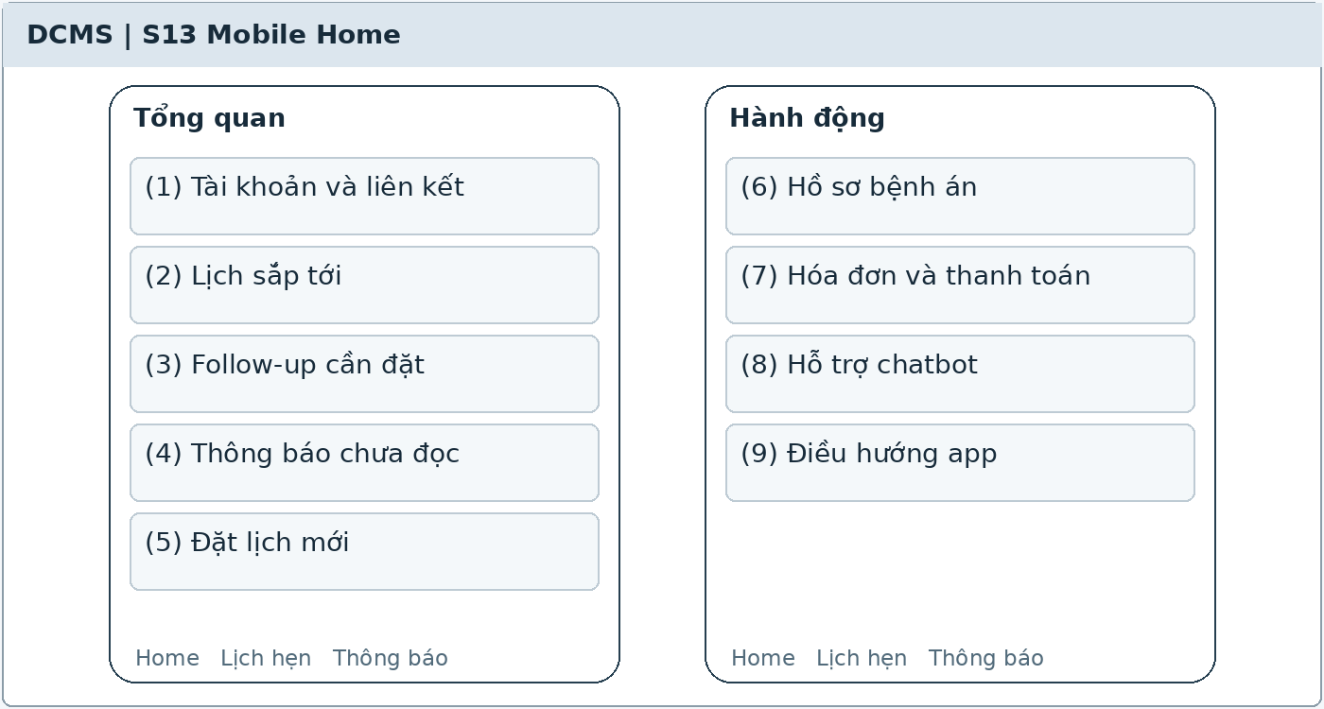
Illustrative UI layout Numbers in the image correspond to the field table on the next page
Functional Description and Use Cases
The app home page combines upcoming appointments belonging to the account, the patient's own follow-up needs, notifications, and suitable actions. Without a link, show verification guidance instead of medical record data.
Roles: Guest account; Patient with a Verified link for their own data.
Mapping: UC-05, UC-17, UC-34. References: MB-04, FU-01–FU-05, NT-01, MR-01.
Rules and Outcomes
• Appointments booked for others display minimal booking information and do not open relatives' records.
• Follow-up needs without bookings still appear when the Patient has sufficient permissions.
• Buttons and data update when the account is locked or the link is revoked.

Field Description S13
Mobile Home | 7.1.1
Field Name | Description
Overview
(1) Account and link | Display name, account status, and link status; read-only from the session; the link button opens S07.
(2) Upcoming appointments | Cards showing time, dentist, attendee, and status; sourced from account bookings and authorized own appointments; open S16.
(3) Follow-up to book | Card with instruction, date range, duration, and overdue flag; only for a Verified self-record link; opens S15 with prefilled criteria.
(4) Unread notifications | Nonnegative integer; count authorized notifications; opens S26; a sent push is not treated as read.
Actions
(5) Book new appointment | Button that opens S15; Guests do not have to sign in to book.
(6) Medical records | Button that opens S41; without Verified, show linking guidance rather than a PatientId selector.
(7) Invoices and payments | Button that opens S42 for the patient's own invoices; third-party payers use separately issued restricted payment requests.
(8) Chatbot support | Button that opens S29; do not automatically pass the entire medical record into the conversation.
(9) App navigation | Home, Appointments, Notifications, and Account [PROPOSED]; consistent positions and retained selected tab.

The common conventions for permissions, input data, error states, pagination, and concurrent operations also apply. [PROPOSED] identifies a limit or design choice requiring confirmation; it does not replace business rules in the source.

7.2 Appointment List

7.2.1 My Appointments
Screen ID S14 | Patient app / public web
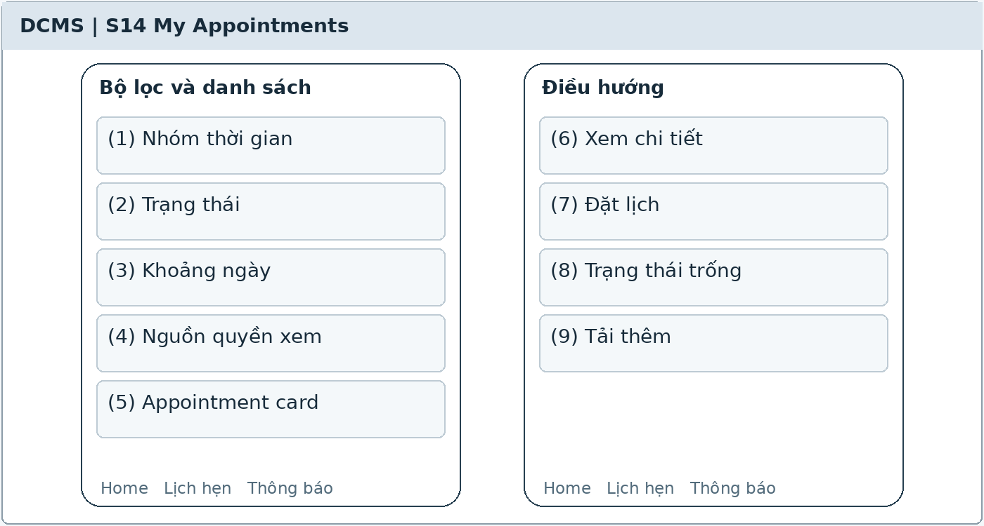
Illustrative UI layout Numbers in the image correspond to the field table on the next page
Functional Description and Use Cases
Lists appointments created by the account, including bookings for others, and the patient's own appointments from a Verified link. Deduplicate by booking code when an appointment appears under both permission sources.
Roles: Guest or Patient account.
Mapping: UC-05. References: MB-04, MB-06, MR-02.
Rules and Outcomes
• Do not display other appointments simply because they share a phone number.
• Bookings for others do not open relatives' medical records, follow-ups, or history.
• Guests without accounts use the appointment code and contact staff; they cannot query this full list.

Field Description S14
My Appointments | 7.2.1
Field Name | Description
Filters and List
(1) Time group | Upcoming or History; defaults to Upcoming [PROPOSED]; clinic local dates.
(2) Status | All or an official appointment status; defaults to All; filter within the authorized dataset.
(3) Date range | Optional; start date must not follow end date; does not expand permissions.
(4) Viewing permission source | Label: Appointments I booked or My own appointments; read-only; the booker's account does not grant access to clinical records.
(5) Appointment card | Code, date, time, dentist, attendee, and status; minimum details sufficient to identify the booking; no clinical conclusions.
Navigation
(6) View details | Open S16 and recheck permissions for each appointment code; do not trust URL parameters.
(7) Book appointment | Button that opens S15; return to the list and refresh after success.
(8) Empty state | Show No appointments in this scope; add linking guidance if the account is not Verified.
(9) Load more | Pagination [PROPOSED]; loading must not duplicate bookings; require sign-in again if the session expires.

The common conventions for permissions, input data, error states, pagination, and concurrent operations also apply. [PROPOSED] identifies a limit or design choice requiring confirmation; it does not replace business rules in the source.

7.3 Own Medical Records

7.3.1 My Medical Records
Screen ID S41 | Patient app / public web
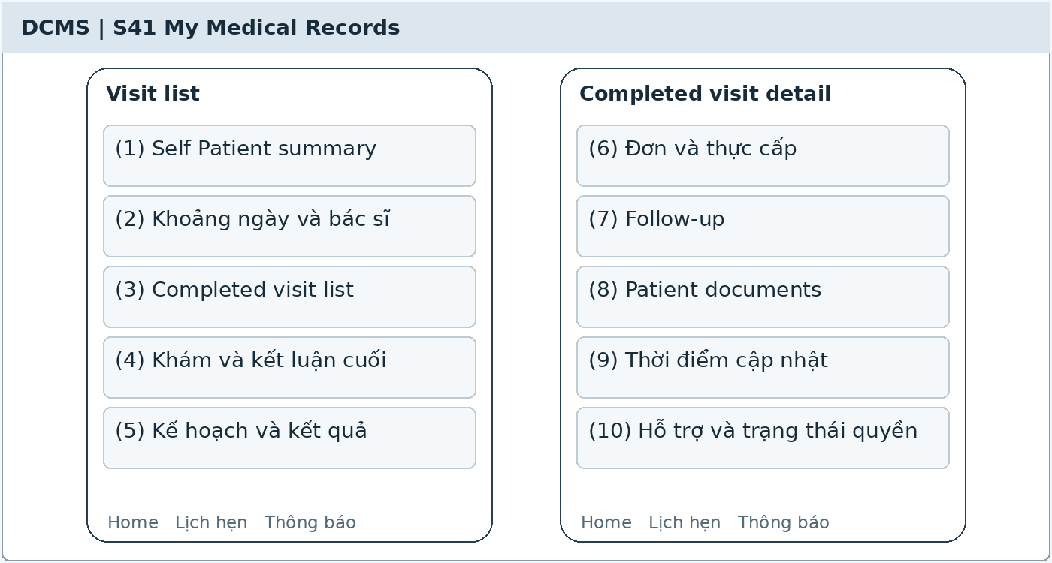
Illustrative UI layout Numbers in the image correspond to the field table on the next page
Functional Description and Use Cases
A list → detail screen for the patient's own completed records and authorized documents. The visit list leads to details of the dentist's conclusions, treatment, prescriptions, instructions, and corresponding follow-up.
Roles: Signed-in Patient with an active account and a Verified link to their own record.
Mapping: UC-37. References: MR-01–MR-08.
Rules and Outcomes
• Do not allow PatientId selection to grant access; an account reads only its Verified self-record.
• Hide drafts, internal notes, and raw AI suggestions; show only the latest valid completed content.
• Patients have read-only access; corrections require contacting the clinic, with no clinical editing or deletion.

Field Description S41
My Medical Records | 7.3.1
Field Name | Description
Own Record List
(1) Self Patient summary | Code, name, identity details, and confirmed health information; the server derives PatientId from the link rather than accepting arbitrary selection.
(2) Date range and dentist | Filters on the patient's own completed Visits; newest first by default [PROPOSED]; search must not expose other Patients.
(3) Completed visit list | Date, dentist, and reason for visit; completed Visits only; drafts do not appear; click a row to open details.
Details and Documents
(4) Examination and final conclusions | Condition, dentist's conclusions, advice, and recorded performed services; do not display internal AI assessment content.
(5) Plans and outcomes | Options recorded for discussion with the Patient, decisions, and outcomes; do not automatically publish all internal Plan notes.
(6) Prescriptions and actual dispensing | Completed prescriptions and care instructions; distinguish prescribed and actually dispensed quantities; prescribing alone must not be reported as dispensing.
(7) Follow-up | Reason, deadline, status, and authorized related appointments; booking opens S15; viewing does not mark Completed.
(8) Patient documents | Only images/radiographs or documents belonging to the correct record, linked to a completed Visit, and Patient-visible; recheck permissions on every open or download.
(9) Last update | Visit date and latest valid update; do not show a draft version in place of official conclusions.
(10) Support and access status | S29 button to report errors; lack of Verified status, a locked account, or Revoked link blocks new reads and explains how to contact the clinic; reads are logged.

The common conventions for permissions, input data, error states, pagination, and concurrent operations also apply. [PROPOSED] identifies a limit or design choice requiring confirmation; it does not replace business rules in the source.

7.4 Own Bills and Payments

7.4.1 My Invoices and Payments
Screen ID S42 | Patient app / public web
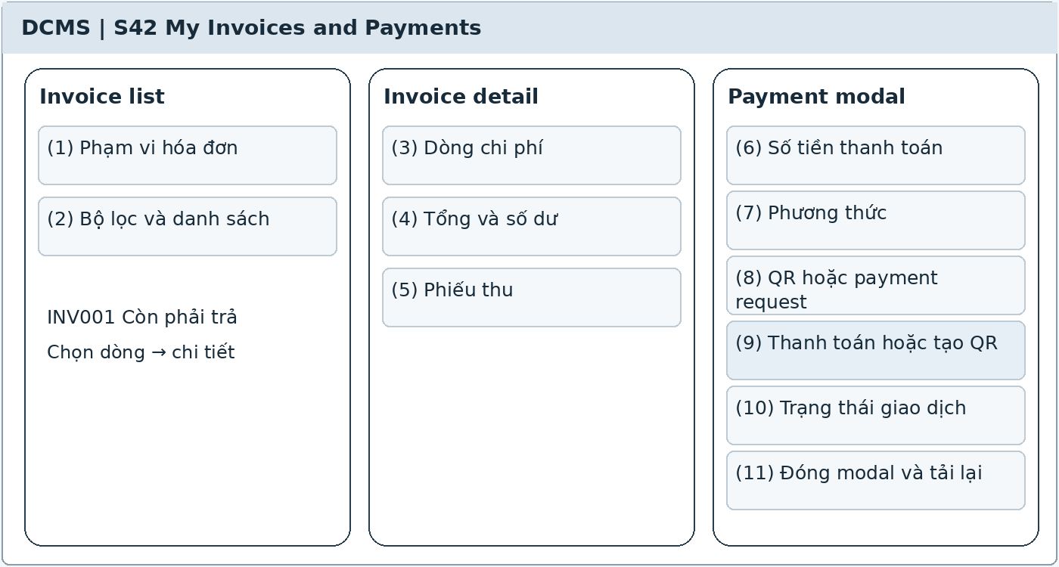
Illustrative UI layout Numbers in the image correspond to the field table on the next page
Functional Description and Use Cases
A list → detail + modal screen where Patients view their own invoices and balances, make payments, and view receipts. Third-party payers may scan a QR code by invoice code without the DCMS app, but cannot open full records.
Roles: Patient with a Verified self-record link; third-party payers only through restricted payment requests.
Mapping: UC-19, UC-20. References: FN-04–FN-10, FN-13, MB-04, MR-08, section 14.
Rules and Outcomes
• Booking for relatives does not grant access to their invoices.
• Record a payment only after an authenticated Payment Gateway result; closing a modal or providing a transfer screenshot is insufficient proof.
• Installment payments remain Partially paid while a balance remains; no refund action exists.

Field Description S42
My Invoices and Payments | 7.4.1
Field Name | Description
Invoice List and Details
(1) Invoice scope | The patient's own record from a Verified link; requested BillId is checked on the server. Third-party payer channels provide only the minimum information needed for payment.
(2) Filters and list | Not fully paid, Paid, or All [PROPOSED]; default Not fully paid; cards showing Bill code, date, total, and balance.
(3) Charge lines | Performed services and chargeable medicines actually dispensed/used; name, quantity, agreed price, adjustments, and line amount; do not display internal drafts.
(4) Total and balance | Read-only total, allocated amount, remaining deposit, and amount due; deposit allocation is not counted as a new payment received.
(5) Receipts | List of confirmed payments, dates, methods, and receipt codes; open details or download according to permissions; transactions awaiting reconciliation are not completed receipts.
Payment modal
(6) Payment amount | VND amount greater than 0, up to the outstanding amount in the Bill modal [PROPOSED]; defaults to the current balance; deposits use a separate finalized process.
(7) Method | Gateway or Transfer/QR according to integration; Cash displays instructions to pay at the counter and does not automatically confirm receipt of cash.
(8) QR or payment request | Request code, Bill, amount, and expiry returned by the service; QR codes contain no medical records or clinical data.
(9) Pay or create QR | Button; recheck Bill permissions, balance, and amount. Send one request with a duplicate-prevention key, open hosted payment or show QR according to the method; clicking alone does not create a receipt.
(10) Transaction status | Processing, Successful, Failed, or Awaiting reconciliation according to actual data; a timeout does not establish whether payment was received.
(11) Close modal and refresh | Closing does not cancel a successful payment; reload the balance from the server; duplicate callbacks record only one payment; Paid applies only when fully paid.

The common conventions for permissions, input data, error states, pagination, and concurrent operations also apply. [PROPOSED] identifies a limit or design choice requiring confirmation; it does not replace business rules in the source.

8 Reception

8.1 Today Queue

8.1.1 Today Reception and Waiting Queue
Screen ID S17 | Staff web
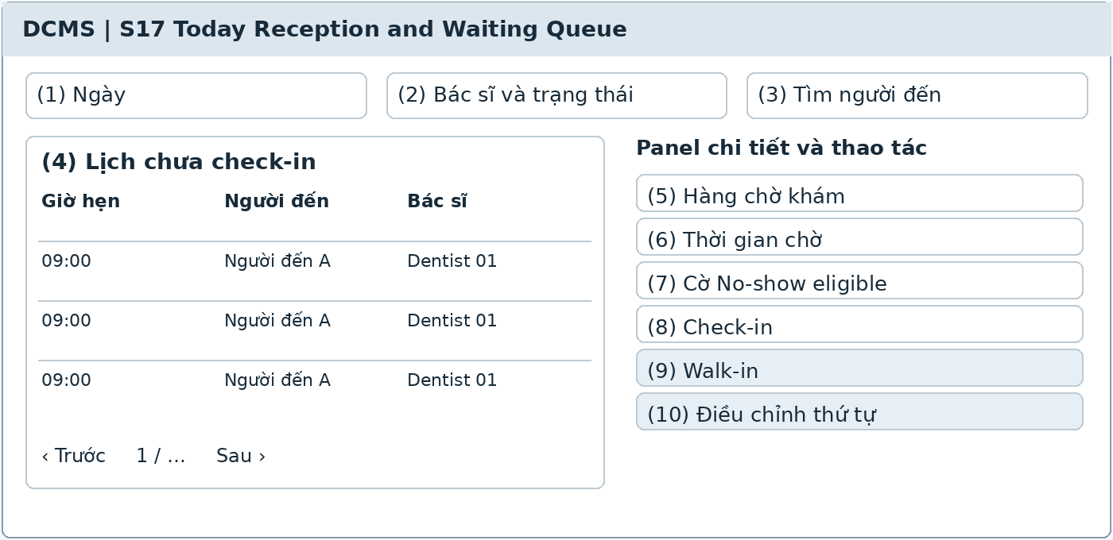
Illustrative UI layout Numbers in the image correspond to the field table on the next page
Functional Description and Use Cases
The daily reception page separates appointments not yet arrived from visits already in the waiting queue. It shows No-show eligible appointments and callback tasks; automatic No-show transitions are handled by a background job.
Roles: Clinic Assistant; Dentist reads the relevant queue.
Mapping: UC-05, UC-07, UC-24. References: AP-07–AP-10, AP-16–AP-18.
Rules and Outcomes
• Only check-in creates a visit and adds it to the waiting queue.
• No-show applies only to Confirmed appointments not checked in 15 minutes after the start time, after checking the latest status.
• Do not change queue order for clinical reasons without a dentist's decision.

Field Description S17
Today Reception and Waiting Queue | 8.1.1
Field Name | Description
Today's Scope
(1) Date | Defaults to today in clinic time; other dates may be viewed according to permissions; use Today in the heading only when the selected date is the current date.
(2) Dentist and status | Filters; defaults to all authorized data; distinguish Appointment and Visit statuses.
(3) Find attendee | String of 0–100 characters [PROPOSED]; search name, appointment code, or Patient code within the selected scope.
Reception and Waiting Queue
(4) Appointments not checked in | Table of code, time, attendee, booker, dentist, and status; Confirmed rows open S18.
(5) Waiting queue | Table of Patient, appointment time, arrival time, dentist, and Visit status: Waiting, In progress, Completed, Cancelled.
(6) Waiting time | Nonnegative minutes calculated from actual arrival time [PROPOSED]; update the display; does not replace clinical priority.
(7) No-show eligible flag | Read-only from AP-16 conditions; do not overwrite appointments that have just been checked in; view callback tasks in S25.
(8) Check-in | Button that opens S18 for Confirmed appointments; does not bypass verification of the actual attendee.
(9) Walk-in | Button that first opens S11 to find an available period; appointments on other dates cannot enter the current queue.
(10) Adjust queue order | Assistant action with a reason; clinical priority records the deciding dentist; do not silently edit appointment times.

The common conventions for permissions, input data, error states, pagination, and concurrent operations also apply. [PROPOSED] identifies a limit or design choice requiring confirmation; it does not replace business rules in the source.

8.2 Attendance Verification

8.2.1 Check In and Walk In
Screen ID S18 | Staff web
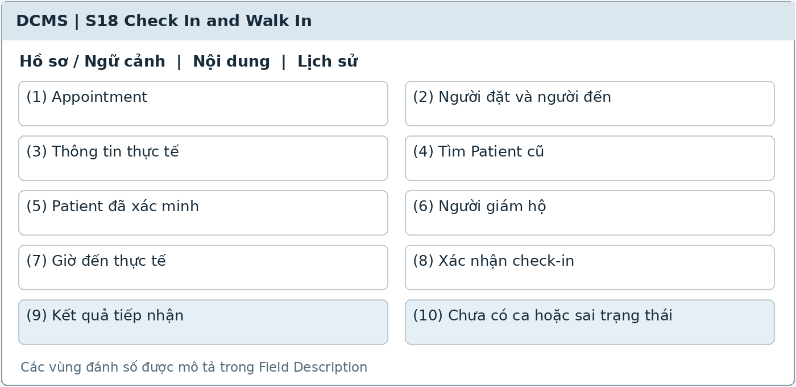
Illustrative UI layout Numbers in the image correspond to the field table on the next page
Functional Description and Use Cases
Verify the actual attendee, match an existing record or create a Patient at first check-in, link the booking, record arrival time, and create one Visit. Walk-ins must have a valid Confirmed appointment before this step.
Roles: Clinic Assistant.
Mapping: UC-07, UC-04, UC-08, UC-09. References: AP-07, AP-09, PT-01–PT-05, BR-16.
Rules and Outcomes
• Do not assume the attendee is the booker; do not merge Patients by phone number.
• Retrying check-in must not create additional Patients, Visits, or queue entries.
• After No-show, assess reception availability through S12/S11; do not check in again against an elapsed slot.

Field Description S18
Check In and Walk In | 8.2.1
Field Name | Description
Appointment and Attendee Verification
(1) Appointment | Select or prefill a Confirmed code; show dentist, time, and expected attendee; validate status on confirmation.
(2) Booker and attendee | Read-only booking details and an actual-identity verification group; the actual attendee must be checked before linking the record.
(3) Actual information | Name and phone required; date of birth, gender, and address if available; same limits as S05.
(4) Find existing Patient | Look up code, name, or contact; display date of birth for comparison; a shared phone number must not automatically select a record.
Record and Visit
(5) Verified Patient | Select exactly one existing record or Create at first check-in; warn about potential duplicates before creation.
(6) Guardian | Name, relationship, and contact when representation is needed; do not grant app access to the guardian.
(7) Actual arrival time | Datetime; defaults to now; for retrospective entry, store actual and entry times separately with a reason [PROPOSED].
(8) Confirm check-in | Button after comparison; one operation links the Patient, changes to Checked-in, and creates one Waiting Visit and one queue row.
(9) Reception result | Read-only Patient code, Visit code, and arrival time; links to S06 or S17.
(10) No appointment or invalid status | Message and guidance to S11/S12; do not create a Visit for another day's booking or an invalid slot.

The common conventions for permissions, input data, error states, pagination, and concurrent operations also apply. [PROPOSED] identifies a limit or design choice requiring confirmation; it does not replace business rules in the source.

9 Examination

9.1 Clinical Workspace

9.1.1 Clinical Visit Workspace
Screen ID S19 | Staff web
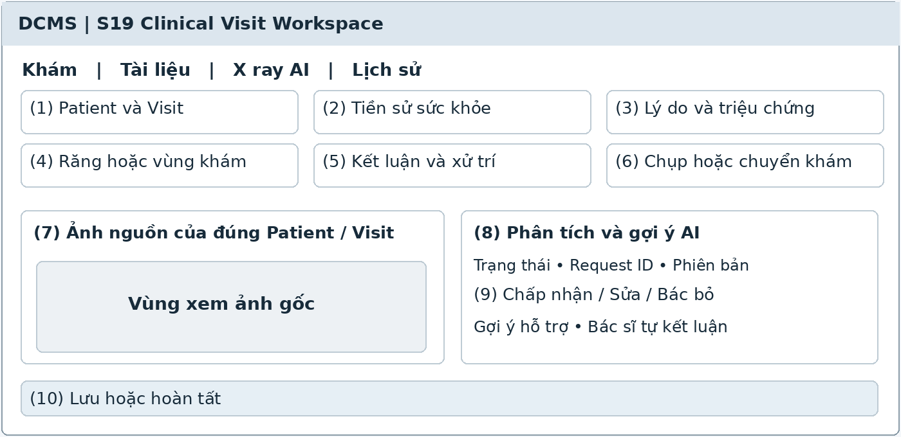
Illustrative UI layout Numbers in the image correspond to the field table on the next page
Functional Description and Use Cases
The Dentist records history, condition, conclusions, and management, requests imaging or referrals, then completes the Visit. The X-ray AI tab is within the workspace, displaying the original image beside suggestions and the dentist's decisions.
Roles: Dentist; Clinic Owner inherits Dentist.
Mapping: UC-10, UC-16, UC-12. References: EX-01–EX-09, XR-AI-01–XR-AI-07, PT-06–PT-07.
Rules and Outcomes
• Dentists enter and confirm clinical content themselves; assistants do not record conclusions on their behalf.
• AI does not automatically create diagnoses, plans, prescriptions, or payments; AI errors do not block manual examination.
• Visit completion does not require treatment or full payment; post-completion edits retain versions and reasons.

Field Description S19
Clinical Visit Workspace | 9.1.1
Field Name | Description
Identity and Examination
(1) Patient and Visit | Code, name, date of birth, dentist, and reception time; read-only and always visible; URL edits must not change the patient.
(2) Medical history | History, allergies, current medications, and Unknown or None states; the dentist rechecks before management.
(3) Reason and symptoms | Long string of up to 4,000 characters [PROPOSED]; use the booking reason as a suggestion and have the dentist verify actual content.
(4) Tooth or examination region | One tooth, multiple teeth, a jaw region, or the whole jaw; selection follows the finalized dental chart; notes up to 4,000 characters [PROPOSED].
(5) Conclusions and management | Dentist-entered content up to 4,000 characters per item [PROPOSED]; conclusions are not automatically taken from AI. Required before completion under the finalized clinical form.
(6) Imaging or referral | Request type, imaging region, destination, and results if available; PACS is conditional and manual document entry remains available.
X-ray AI and Completion
(7) Source image | Select a valid X-ray file for the correct Patient and Visit; check quality, identity, permissions, and the basis for data processing before analysis.
(8) AI analysis and suggestions | Explicit request button; show request ID, status, model version, findings or annotations, and confidence if available. Do not present suggestions as diagnoses.
(9) Dentist's decision | Accept, modify, or reject each suggestion with comments; display the original image alongside; do not publish raw suggestions to the Patient.
(10) Save or complete | Save a draft; completion is confirmed by the dentist. After completion, update Visit and Appointment to Completed; additions must retain the old version, reason, actor, and time.

The common conventions for permissions, input data, error states, pagination, and concurrent operations also apply. [PROPOSED] identifies a limit or design choice requiring confirmation; it does not replace business rules in the source.

9.2 Clinical File Management

9.2.1 Clinical Documents
Screen ID S20 | Staff web
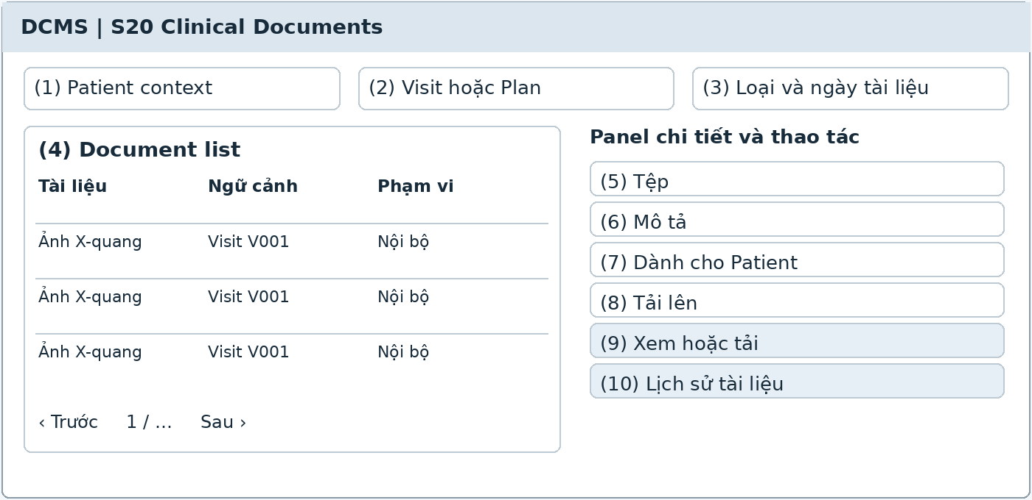
Illustrative UI layout Numbers in the image correspond to the field table on the next page
Functional Description and Use Cases
Document list and viewer by Patient, Visit, or plan. The upload panel defines context, document type, and the permitted publication scope for the Patient.
Roles: Clinic Assistant uploads and manages according to permissions; Dentist manages clinical content.
Mapping: UC-11, UC-12. References: EX-05–EX-06, XR-AI-01, MR-05, MR-07.
Rules and Outcomes
• Visit documents link to the correct Visit; long-term documents may link to a Plan, and general documents to a Patient.
• File opening and direct links must check permissions; hiding buttons alone is insufficient.
• Without PACS integration, upload manually; raw AI suggestions do not become documents published for the patient's own access.

Field Description S20
Clinical Documents | 9.2.1
Field Name | Description
Context and List
(1) Patient context | Read-only code and identity; required before document access; changes to PatientId must not bypass permissions.
(2) Visit or Plan | The selected code must belong to the current Patient, depending on document type; do not link another person's Visit or Plan.
(3) Document type and date | Filters for radiographs, images, results, consent forms, or other [PROPOSED]; defaults to All.
(4) Document list | Name, type, context, date, uploader, and Patient-visible scope; click to open the viewer or download according to permissions.
Upload and Publication
(5) File | File selection; name up to 255 characters [PROPOSED]. Supported types and maximum size require confirmation; do not automatically promise support for all DICOM files.
(6) Description | String of 0–1,000 characters [PROPOSED]; describe purpose and source; avoid unnecessary identifying data in filenames.
(7) Patient-visible | Boolean; defaults to No [PROPOSED]; publish only for the correct record, a completed Visit, and a scope confirmed by an authorized person.
(8) Upload | Button that checks type, size, identity links, and permissions; failed files must not appear as successful uploads.
(9) View or download | Buttons; check permissions each time; locked accounts or Revoked links reject new requests.
(10) Document history | Read-only actor, time, PACS or manual source, context, and changes; do not delete the audit trail of documents used as evidence.

The common conventions for permissions, input data, error states, pagination, and concurrent operations also apply. [PROPOSED] identifies a limit or design choice requiring confirmation; it does not replace business rules in the source.

10 Treatment

10.1 Treatment Planning

10.1.1 Treatment Plan
Screen ID S21 | Staff web
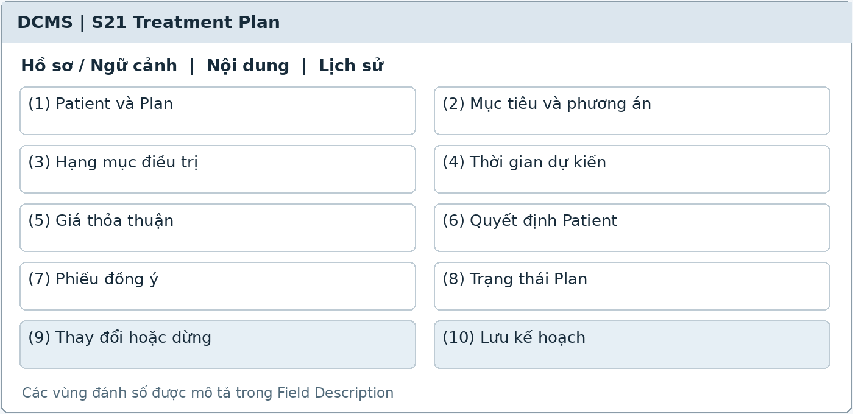
Illustrative UI layout Numbers in the image correspond to the field table on the next page
Functional Description and Use Cases
The Dentist creates and edits multi-session plans, records advised options, Patient decisions, items, and agreed prices. Simple cases may be recorded directly in S22 without a mandatory Plan.
Roles: Dentist; Clinic Owner inherits Dentist.
Mapping: UC-13. References: TR-01–TR-05, TR-07–TR-10.
Rules and Outcomes
• Retain agreed prices even if the Service Catalog changes.
• Additional items or changed options are recorded separately with costs and the Patient's decision.
• A Plan with performed activities that stops midway uses Discontinued and retains the entire history.

Field Description S21
Treatment Plan | 10.1.1
Field Name | Description
Plan
(1) Patient and Plan | Patient required from context; system-generated PlanId is read-only; source visit if available.
(2) Goals and options | String of 1–4,000 characters [PROPOSED]; goals, advice, and options; initially blank for a new plan.
(3) Treatment items | List of services, teeth or regions, units, quantities, and planned sequence; service codes reference the active catalog.
(4) Estimated timing | Date or date range; start date must not follow end date; does not automatically create bookings.
(5) Agreed price | Nonnegative VND amount; saved per item or package; retain unit and price snapshots without updating to new catalog prices.
Decision and Progress
(6) Patient decision | Agreed, Undecided, or Declined under TR-03; store the time and relevant counseling content.
(7) Consent form | Optional file linked to the correct Patient and Plan; managed in S20; a file alone does not replace the decision.
(8) Plan status | Proposed, In treatment, Completed, Discontinued, Cancelled; transitions only through valid progress.
(9) Change or discontinue | Reason string of 1–1,000 characters [PROPOSED]; retain the old option, additional costs, decision, and time; do not delete a Plan with performed activities.
(10) Save plan | Button; check permissions and version; proposed items alone do not create a payment received.

The common conventions for permissions, input data, error states, pagination, and concurrent operations also apply. [PROPOSED] identifies a limit or design choice requiring confirmation; it does not replace business rules in the source.

10.2 Performed Services

10.2.1 Treatment Activity
Screen ID S22 | Staff web
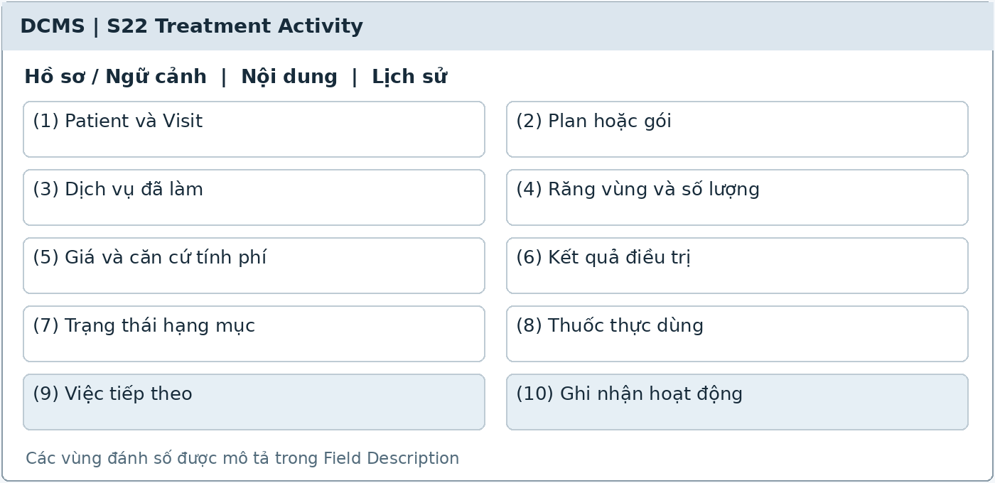
Illustrative UI layout Numbers in the image correspond to the field table on the next page
Functional Description and Use Cases
Record services performed during a Visit and clinical outcomes, linked to a Plan or package if applicable. Medicines actually used open the S37 panel according to the dentist's treatment recording permissions.
Roles: Dentist; Clinic Owner inherits Dentist.
Mapping: UC-14, UC-18. References: TR-01, TR-06, TR-10, MD-09, FN-04.
Rules and Outcomes
• A proposed service or Patient agreement is not considered a performed service.
• Link packages to prevent duplicate charges per session; medicines in packages still record quantities and batches.
• Dentists record medicines actually used in treatment under UC-18; they do not dispense medicines or manage inventory.

Field Description S22
Treatment Activity | 10.2.1
Field Name | Description
Visit Activities
(1) Patient and Visit | Required from the workspace; read-only; do not select another Patient's visit.
(2) Plan or package | Optional; select a plan belonging to the Patient; may be blank for simple cases. Package items must have a package link.
(3) Performed services | Select services and describe actual work; do not automatically copy all proposed items into performed services.
(4) Teeth regions and quantities | Regions follow the finalized chart; quantity greater than 0 in units of session, tooth, jaw, or package; validate precision appropriate to the unit [PROPOSED].
(5) Price and charging basis | Agreed price from the Plan or performed session; nonnegative VND; record included in package, separately charged, or free; do not charge the package twice.
Outcomes and Next Steps
(6) Treatment outcome | String up to 4,000 characters [PROPOSED]; performer and time; clinical content confirmed by the dentist.
(7) Item status | Proposed, Agreed, In progress, Completed, or Cancelled; tracked separately from Plan status.
(8) Medicines actually used | Link batch documents, quantities, and charging modes in S37; only actual use reduces stock.
(9) Next steps | String up to 2,000 characters [PROPOSED]; if a return visit is needed, create an instruction in S24 rather than an isolated note.
(10) Record activity | Button that saves performance and outcomes; prevents duplicate charging sources and retains important change history.

The common conventions for permissions, input data, error states, pagination, and concurrent operations also apply. [PROPOSED] identifies a limit or design choice requiring confirmation; it does not replace business rules in the source.

11 Prescription

11.1 Prescription Authoring

11.1.1 Prescription Editor
Screen ID S23 | Staff web
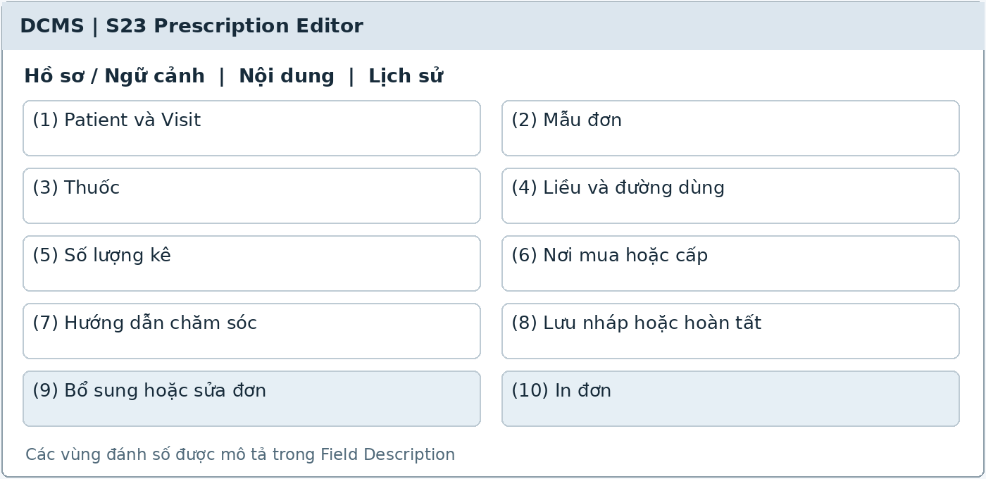
Illustrative UI layout Numbers in the image correspond to the field table on the next page
Functional Description and Use Cases
The Dentist creates, completes, and supplements a Visit prescription; templates may be used and then adapted to the Patient. Prescribing and dispensing are separate processes.
Roles: Dentist; Clinic Assistant views or prints completed prescriptions according to permissions.
Mapping: UC-15. References: RX-01–RX-07, MD-07–MD-08, MD-17.
Rules and Outcomes
• Completing a prescription does not reduce stock or automatically charge for medicines.
• Prescriptions purchased elsewhere do not issue stock or create medicine charges at the clinic.
• Editing a completed prescription retains the previous version and reason without losing the basis of prior dispensing events.

Field Description S23
Prescription Editor | 11.1.1
Field Name | Description
Context and Templates
(1) Patient and Visit | Required from the visit; read-only; show allergies and history to be checked.
(2) Prescription template | Optional from authorized templates; creates an editable copy, not automatically applied to every Patient.
(3) Medicine | Medicine code, name, active ingredient, strength, and dosage form; identify the correct medicine and do not substitute a similarly named medicine.
Medicine Lines and Instructions
(4) Dose and route | Dose, route, frequency, and duration; strings up to 500 characters per instruction [PROPOSED]; do not infer inventory quantities from doses.
(5) Prescribed quantity | Greater than 0 in the prescribing unit; check conversion when dispensed at the clinic; inventory base quantities use whole stock units.
(6) Purchase or dispensing location | At clinic or Purchase elsewhere; this instruction does not mean dispensing has occurred.
(7) Care instructions | String of 0–4,000 characters [PROPOSED]; saved with the prescription version; follow-up managed separately in S24.
(8) Save draft or complete | Dentist buttons; completion retains a snapshot of medicine content and instructions; only completed prescriptions are eligible for dispensing.
(9) Supplement or edit prescription | Reason of 1–1,000 characters [PROPOSED]; retain the prior version, actor, time, and dispensing events referencing the correct prescription version.
(10) Print prescription | Button for completed prescriptions; assistants may print according to permissions; does not create additional stock issues or invoices.

The common conventions for permissions, input data, error states, pagination, and concurrent operations also apply. [PROPOSED] identifies a limit or design choice requiring confirmation; it does not replace business rules in the source.

12 Follow up

12.1 Clinical Follow up Instruction

12.1.1 Follow-up Instruction
Screen ID S24 | Staff web
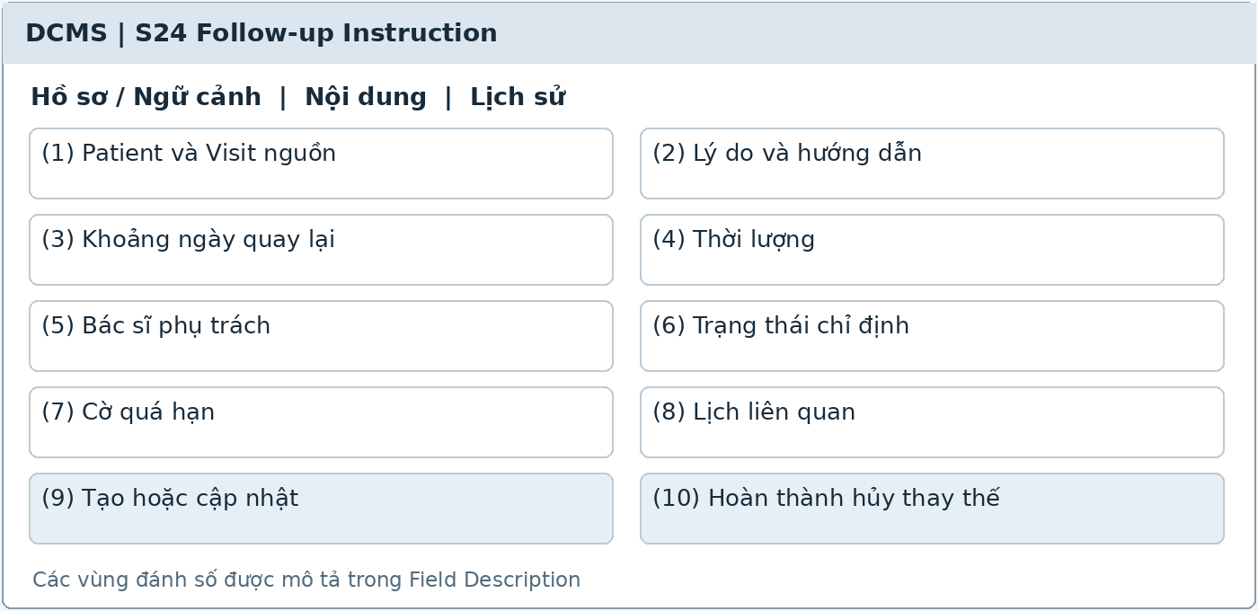
Illustrative UI layout Numbers in the image correspond to the field table on the next page
Functional Description and Use Cases
Record return-visit needs independently of booking, including reason, date range, duration, and dentist requirements. The screen displays instruction status and related appointment history.
Roles: Dentist; Clinic Owner inherits Dentist.
Mapping: UC-17. References: FU-01–FU-04, AP-12.
Rules and Outcomes
• At most one active appointment per instruction; an appointment links to at most one instruction.
• Cancellation or No-show returns a still-valid instruction to Needs booking.
• Only the dentist confirms Completed; sending reminders, booking, or check-in does not complete the instruction.

Field Description S24
Follow-up Instruction | 12.1.1
Field Name | Description
Instruction Content
(1) Patient and source Visit | Required and for the same Patient; read-only from the visit; instruction code generated by the system.
(2) Reason and instructions | String of 1–2,000 characters for the reason and 0–4,000 for instructions [PROPOSED]; entered by the dentist.
(3) Return date range | Target date or start/end dates; start must not follow end; changes to deadlines must be audited.
(4) Duration | Select 30 or 60 minutes; required; used for slot search, not automatic appointment creation.
(5) Responsible dentist | Specific requirement or finalized dentist criteria; defaults to the instructing dentist [PROPOSED]; do not automatically change dentists when slots are unavailable.
Status and Links
(6) Instruction status | Needs booking, Booked, Completed, Cancelled, Superseded; read-only or actions according to valid states.
(7) Overdue flag | Computed from the planned end date and incomplete status; do not replace the status with Overdue.
(8) Related appointments | Current booking code and history; rescheduling retains the link; do not delete links to cancelled or missed appointments.
(9) Create or update | Dentist button; save actor, time, and version; without a selected time, retain Needs booking.
(10) Complete cancel or supersede | Dentist actions, with a reason for cancellation or replacement; Completed after a suitable follow-up visit; Cancelled/Superseded stops reminders.

The common conventions for permissions, input data, error states, pagination, and concurrent operations also apply. [PROPOSED] identifies a limit or design choice requiring confirmation; it does not replace business rules in the source.

12.2 Staff Follow up Queue

12.2.1 Follow-up Work Queue
Screen ID S25 | Staff web
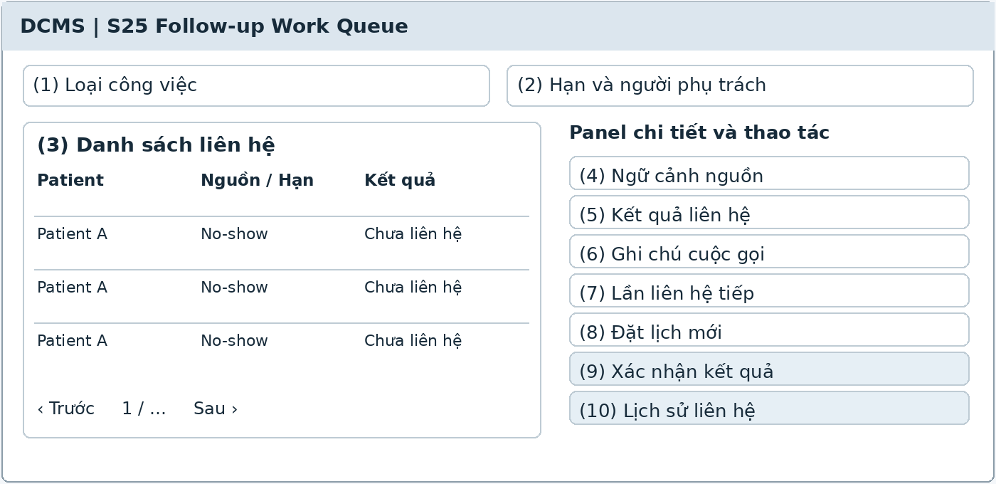
Illustrative UI layout Numbers in the image correspond to the field table on the next page
Functional Description and Use Cases
A queue for contacting Patients who missed appointments, have unbooked follow-ups, or are overdue. Record call results, create new appointments, and retain links to instructions or missed bookings.
Roles: Clinic Assistant.
Mapping: UC-24, UC-25. References: AP-16–AP-17, FU-05, NT-05.
Rules and Outcomes
• Patients without the app still appear in the monitoring list.
• Rerunning the process does not duplicate call tasks for the same event.
• No further need after a call does not automatically cancel a clinical instruction; refer to the dentist for review where needed.

Field Description S25
Follow-up Work Queue | 12.2.1
Field Name | Description
Filters and List
(1) Task type | No-show, Needs booking, Overdue, or Unable to send; defaults to unhandled tasks [PROPOSED].
(2) Deadline and assignee | Date range, status, and assigned Clinic Assistant [PROPOSED]; assignment does not grant clinical permissions.
(3) Contact list | Patient, contact channel, monitoring reason, deadline, source appointment or instruction, and latest result.
Contact and Rebooking
(4) Source context | Read-only No-show Appointment or Follow-up instruction; do not overwrite the old appointment.
(5) Contact result | Not contacted, No answer, Contacted, New appointment booked, No further need; defaults to Not contacted.
(6) Call notes | String of 0–1,000 characters [PROPOSED]; record actor, time, and necessary content; does not decide treatment changes.
(7) Next contact | Optional datetime [PROPOSED]; not a clinical appointment and does not automatically mark the instruction Booked.
(8) Book new appointment | Button that opens S11 with source criteria; record the link and New appointment booked only after success.
(9) Confirm result | Button that saves each contact attempt; prevents duplicates from the same operation; sending reminders does not automatically mark the instruction Completed.
(10) Contact history | Read-only calls, actors, times, and related bookings; retain an audit trail even for unanswered calls.

The common conventions for permissions, input data, error states, pagination, and concurrent operations also apply. [PROPOSED] identifies a limit or design choice requiring confirmation; it does not replace business rules in the source.

13 Notifications

13.1 In app Notices

13.1.1 Notification Center
Screen ID S26 | Patient app / public web
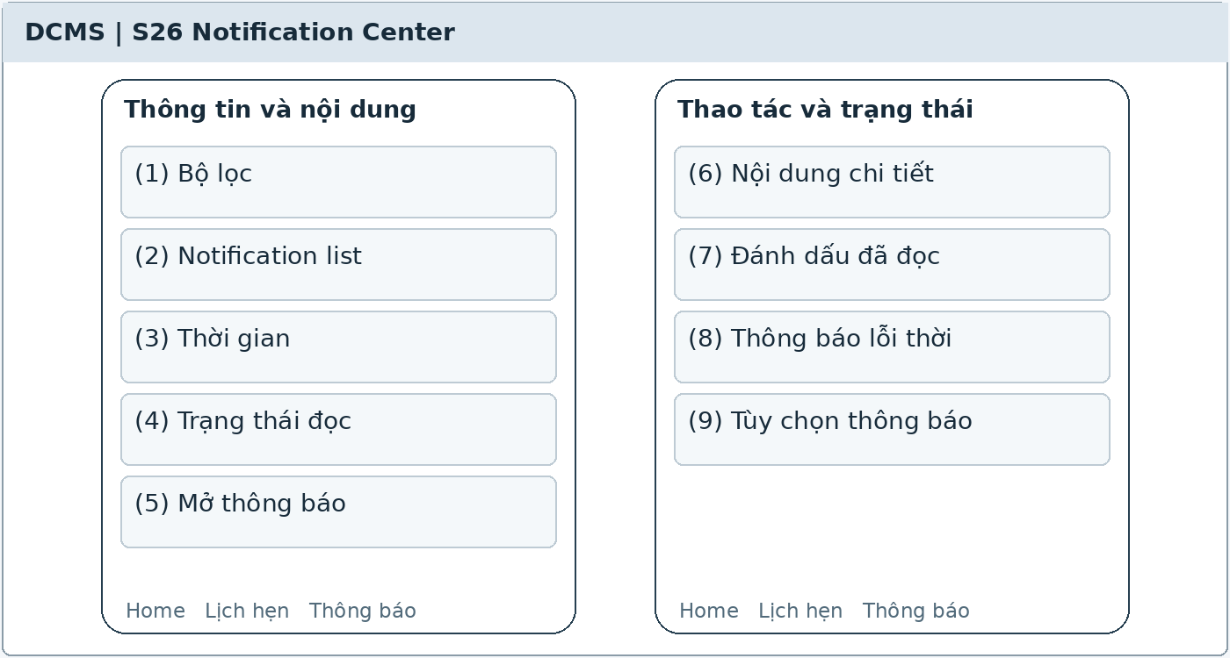
Illustrative UI layout Numbers in the image correspond to the field table on the next page
Functional Description and Use Cases
In-app notifications about booking/rescheduling/cancellation, upcoming appointments, and follow-ups needing booking. Opening a notification leads to its object after permissions are rechecked.
Roles: Guest or Patient account within scope.
Mapping: UC-34. References: NT-01, NT-03–NT-06, MB-04.
Rules and Outcomes
• Receiving a push does not mean it was read; update read state only after the app confirms reading.
• Turning off push does not delete in-app notices.
• Push must not contain diagnoses or prescriptions; locking or Revoked blocks access to data no longer authorized.

Field Description S26
Notification Center | 13.1.1
Field Name | Description
Notification List
(1) Filters | All, Unread, Appointment, or Follow-up [PROPOSED]; defaults to All; filter only the account's notifications.
(2) Notification list | Title, authorized content, type, time, and read state; newest first [PROPOSED].
(3) Time | Datetime in clinic time; retain notification creation time; provider push acceptance time must not be used as read time.
(4) Read status | Unread or Read; initially Unread; update when the app sends valid read confirmation.
Viewing and Navigation
(5) Open notification | Button or row click; authenticate and check permissions for the linked object at opening time.
(6) Detailed content | Only content appropriate to the booking or the patient's own record; do not expose clinical data through general notifications.
(7) Mark as read | Action for notifications belonging to the account [PROPOSED]; push delivery results do not mark a notification as read by the Patient.
(8) Outdated notification | If the booking changes or the link is revoked, show that the object is no longer accessible; do not load old data to bypass permissions.
(9) Notification preferences | Button that opens S27; does not change Appointment or Follow-up status.

The common conventions for permissions, input data, error states, pagination, and concurrent operations also apply. [PROPOSED] identifies a limit or design choice requiring confirmation; it does not replace business rules in the source.

13.2 Push Preferences

13.2.1 Notification Preferences
Screen ID S27 | Patient app / public web
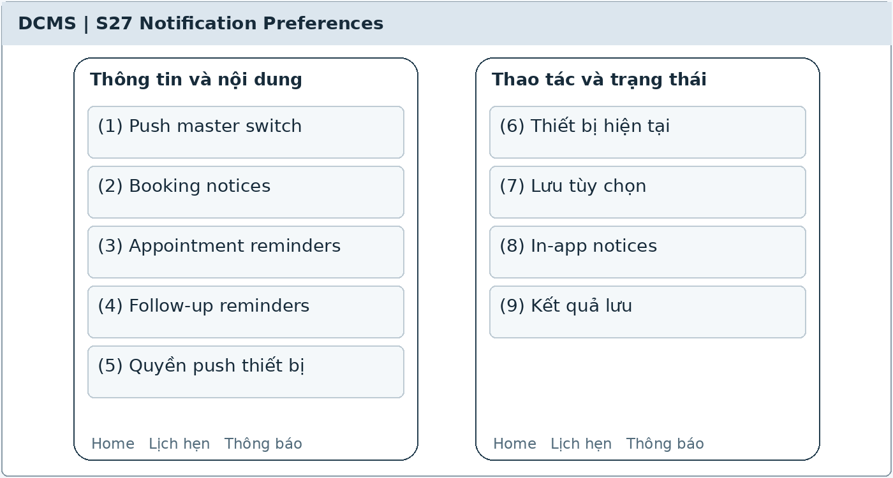
Illustrative UI layout Numbers in the image correspond to the field table on the next page
Functional Description and Use Cases
Account holders manage push preferences; in-app notifications remain available. Send times and reminder counts are clinic configuration and are not independently defined in this form.
Roles: Guest or Patient account holder.
Mapping: UC-34. References: NT-02, NT-05–NT-06.
Rules and Outcomes
• Denying operating-system permission or turning off push does not cancel appointments.
• No valid device creates a condition for manual contact when due.
• Check preference changes before every send; they do not complete instructions.

Field Description S27
Notification Preferences | 13.2.1
Field Name | Description
Account Preferences
(1) Push master switch | Boolean; initial value from saved preferences and device permissions; new accounts require an explicit choice rather than presumed permission.
(2) Booking notices | Boolean [PROPOSED]; applies push for booking/rescheduling/cancellation outcomes within ownership scope; in-app notices are still stored.
(3) Appointment reminders | Boolean [PROPOSED]; applies reminders based on active Appointment times; clinic reminder timings cannot be edited here.
(4) Follow-up reminders | Boolean [PROPOSED]; applies to authorized own follow-up needs without bookings; do not display relatives' data.
Device and Saving
(5) Device push permission | Read-only Allowed, Denied, or Not requested from the operating system; provide guidance to open Settings if denied.
(6) Current device | Push registration status [PROPOSED]; do not display raw tokens or other devices' tokens.
(7) Save preferences | Button; validate the session; record the time and apply to the next send.
(8) In-app notices | Information always available in the app according to permissions; no switch to delete business notifications.
(9) Save result | Success or error message; errors retain current selections for retry; do not report saved when disconnected.

The common conventions for permissions, input data, error states, pagination, and concurrent operations also apply. [PROPOSED] identifies a limit or design choice requiring confirmation; it does not replace business rules in the source.

13.3 Delivery Exceptions

13.3.1 Notification Failure Queue
Screen ID S28 | Staff web
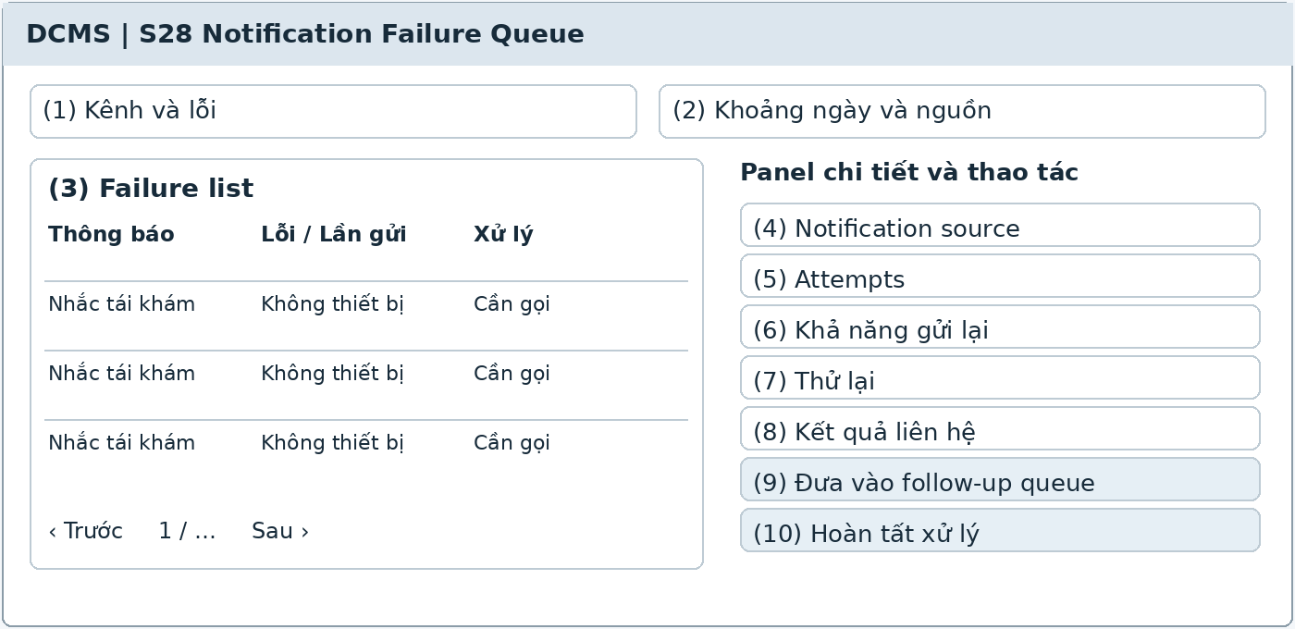
Illustrative UI layout Numbers in the image correspond to the field table on the next page
Functional Description and Use Cases
Displays final delivery failures or cases without a valid channel that require staff contact. Notification lists and individual attempts are retained separately for inspection.
Roles: Clinic Assistant.
Mapping: UC-24, UC-25. References: NT-03–NT-06, FU-05.
Rules and Outcomes
• Delivery failure does not cancel appointments or complete instructions.
• Retries are limited and check that the object and version remain valid.
• Do not resend private content to locked accounts or revoked links.

Field Description S28
Notification Failure Queue | 13.3.1
Field Name | Description
Filters and List
(1) Channel and error | Push, No device, or No account; provider error codes; defaults to cases requiring action.
(2) Date range and source | Filter send date, Appointment, or Follow-up; defaults to the selected operating period [PROPOSED].
(3) Failure list | Person to contact, source notification, latest attempt, error code, and handling status; authorized support staff only.
Attempts and Handling
(4) Notification source | Object code, version, and type; check continued validity before retrying or contacting.
(5) Attempts | List of channels, times, results, and error codes; provider acceptance does not mean Delivered or Read.
(6) Retry eligibility | Read-only; unexpired, authorized, and with configured attempts remaining; show reasons for ineligibility.
(7) Retry | Button when eligible [PROPOSED]; do not create duplicate notifications or exceed provider/system attempt limits.
(8) Contact result | Use S25 results; record actor and time; do not change clinical status.
(9) Add to follow-up queue | Button that opens or links an S25 task; prevents duplicate tasks for the same event.
(10) Complete handling | Record the manual result [PROPOSED]; do not delete failed attempts; retain auditability.

The common conventions for permissions, input data, error states, pagination, and concurrent operations also apply. [PROPOSED] identifies a limit or design choice requiring confirmation; it does not replace business rules in the source.

14 Patient Support

14.1 AI Assisted Support

14.1.1 Patient Chatbot
Screen ID S29 | Patient app / public web
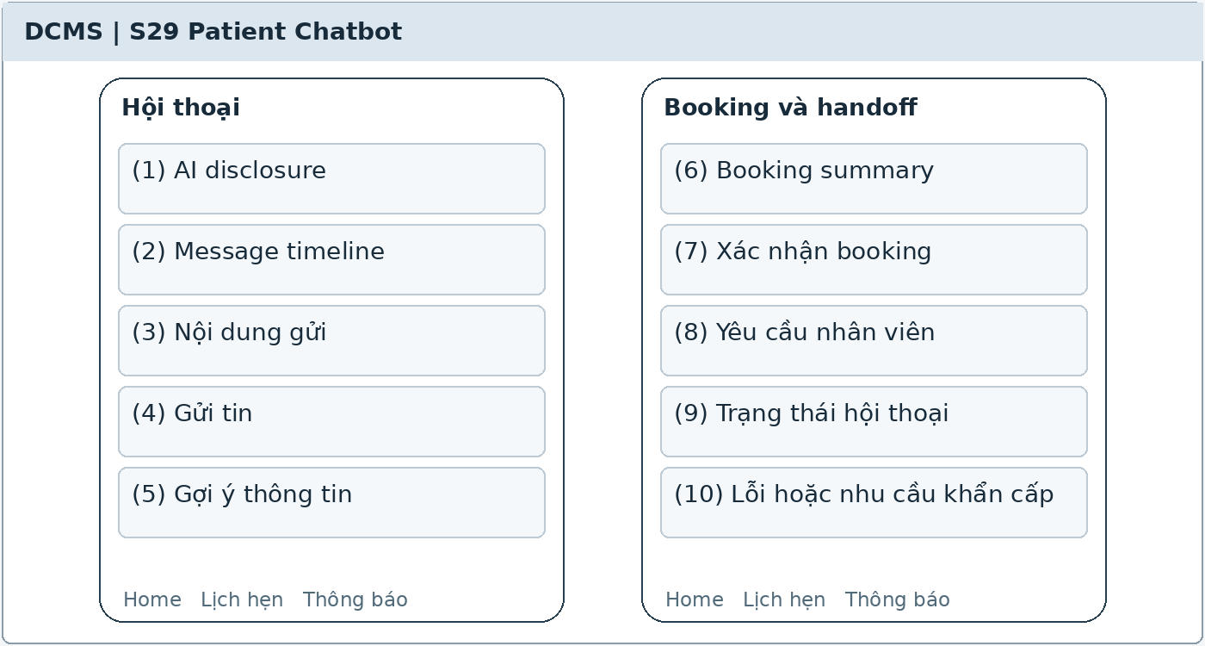
Illustrative UI layout Numbers in the image correspond to the field table on the next page
Functional Description and Use Cases
The chatbot answers from approved clinic content and supports searching and acting on bookings with user confirmation. Hand off to staff when information is insufficient, a request is out of scope, or the user requests it.
Roles: Guest or Patient.
Mapping: UC-35, UC-04, UC-06. References: AI-01–AI-06.
Rules and Outcomes
• Do not diagnose, interpret radiographs, prescribe, or change medication; do not access X-ray AI suggestions.
• Reference prices differ from agreed prices; available periods must come from DCMS.
• AI errors still allow forms to be used; only actual booking results confirm success.

Field Description S29
Patient Chatbot | 14.1.1
Field Name | Description
Conversation
(1) AI disclosure | State that the user is interacting with AI, the support scope, and the finalized retention policy; display before use [PROPOSED].
(2) Message timeline | User, AI, and staff messages; clear times and sources; distinguish AI messages from staff decisions.
(3) Message content | String of 1–2,000 characters [PROPOSED]; initially blank; do not automatically send the full medical record into LLM context.
(4) Send message | Button; includes responding status; AI text alone must not report successful booking.
Booking and Handoff
(5) Information suggestions | Working hours, services, and processes from approved sources; prices labeled as references; do not infer missing data.
(6) Booking summary | Dentist, attendee, time, and booking/rescheduling/cancellation action; explicit user confirmation before server processing.
(7) Confirm booking | Button using the same permissions and 60-minute or 12-hour thresholds as the forms; results retrieved from DCMS.
(8) Request staff | Button or handoff rule; creates Awaiting staff and retains minimal context; do not promise immediate responses outside working hours.
(9) Conversation status | AI support in progress or Awaiting staff; show support updates; final status catalog requires confirmation [PROPOSED].
(10) Error or urgent need | Display clinic channels or approved guidance; urgent needs must not wait for the chatbot or queue; the booking form button remains available.

The common conventions for permissions, input data, error states, pagination, and concurrent operations also apply. [PROPOSED] identifies a limit or design choice requiring confirmation; it does not replace business rules in the source.

14.2 Staff Handoff

14.2.1 Staff Support Inbox
Screen ID S30 | Staff web
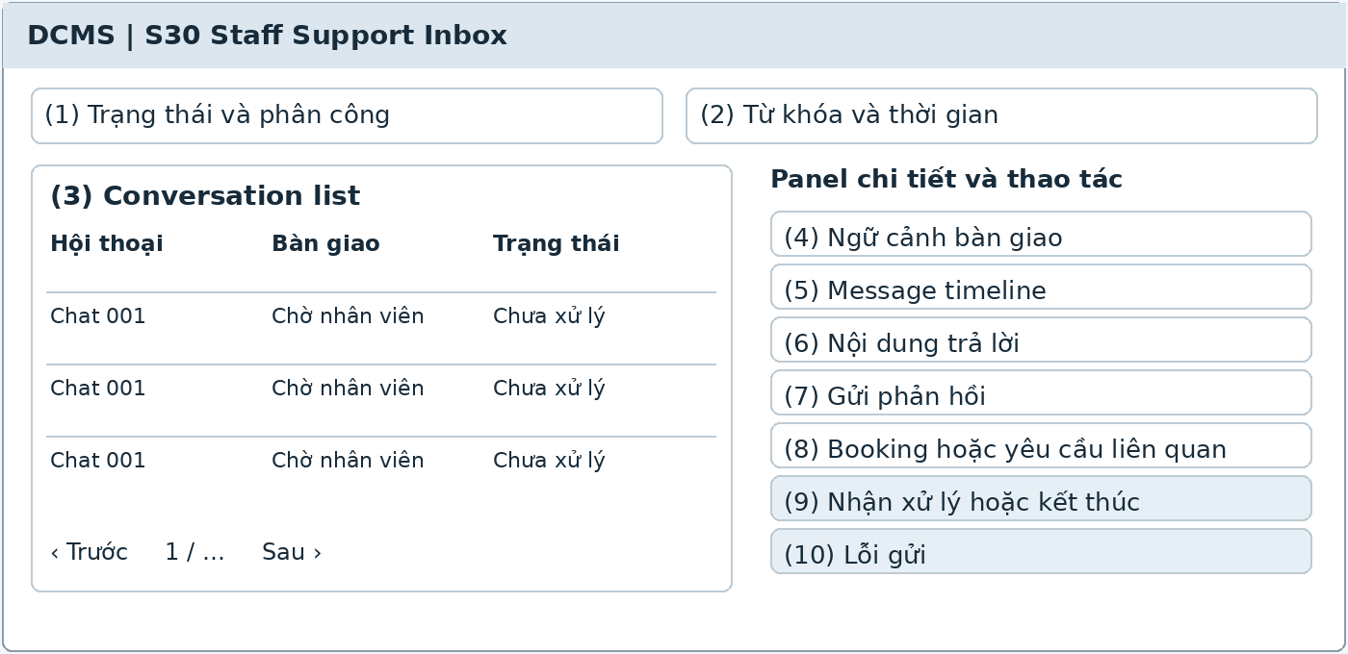
Illustrative UI layout Numbers in the image correspond to the field table on the next page
Functional Description and Use Cases
The assistant views and responds to conversations handed off from the chatbot and receives appointment-change support requests. Conversation context supports assistance and does not expose full medical records.
Roles: Authorized Clinic Assistant.
Mapping: UC-26. References: AI-03, AI-05–AI-06, MB-06.
Rules and Outcomes
• Admins do not automatically have permission to read conversations.
• Staff still check booking permissions and slots; sending a message alone does not change an appointment.
• Do not make clinical decisions; refer treatment questions to the dentist under the process.

Field Description S30
Staff Support Inbox | 14.2.1
Field Name | Description
Inbox
(1) Status and assignment | Awaiting staff, In progress, Resolved [PROPOSED]; filter by assigned assistant; defaults to Awaiting staff.
(2) Keyword and time | String of 0–100 characters and date range [PROPOSED]; search only conversations authorized for support.
(3) Conversation list | Code, display name, latest time, handoff reason, and status; no sensitive content in shared previews.
Content and Handling
(4) Handoff context | Question, minimal summary, and reason; distinguish AI-generated information from verified content.
(5) Message timeline | Patient, AI, and staff messages in order; author source and time; old messages are read-only.
(6) Reply content | String of 1–2,000 characters [PROPOSED]; staff check information before sending; use approved clinic content.
(7) Send reply | Button; store author and time; resubmitting the same operation does not duplicate messages [PROPOSED].
(8) Related booking or request | Authorized codes; open S12 for handling; a booking code does not grant access to the Patient record.
(9) Accept or close case | Status-change buttons [PROPOSED]; record actor and time; retain history and do not delete the conversation.
(10) Send error | Clearly state that the message was not sent; retain the draft for staff to retry; do not simulate delivery to the user.

The common conventions for permissions, input data, error states, pagination, and concurrent operations also apply. [PROPOSED] identifies a limit or design choice requiring confirmation; it does not replace business rules in the source.

15 Service Catalog

15.1 Services and Prices

15.1.1 Service Catalog and Editor
Screen ID S31 | Staff web
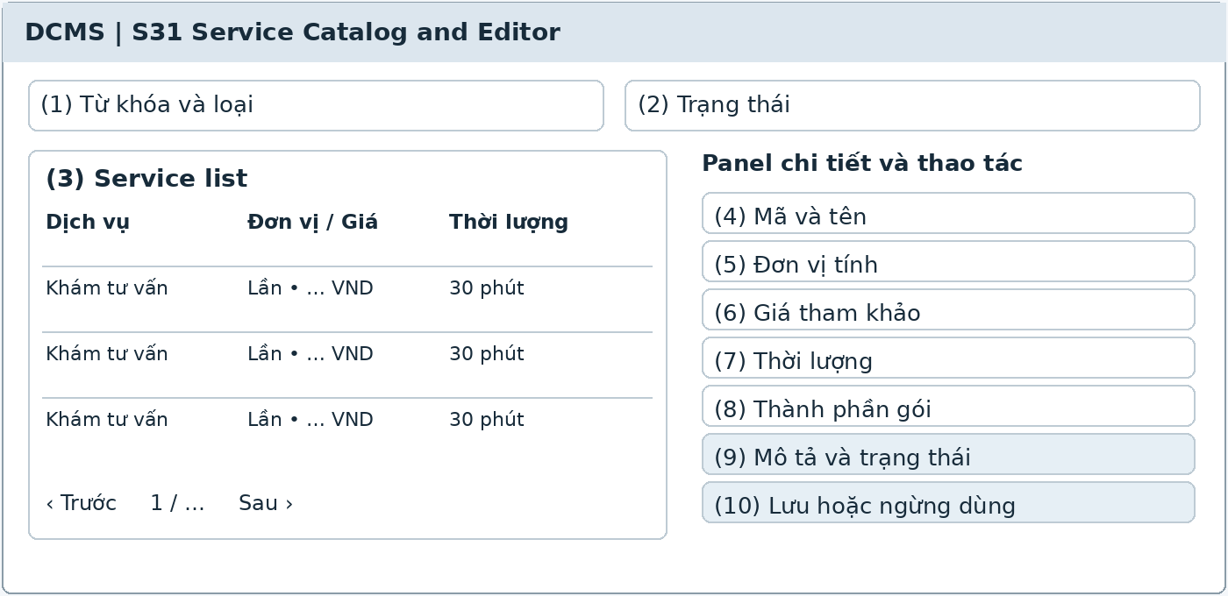
Illustrative UI layout Numbers in the image correspond to the field table on the next page
Functional Description and Use Cases
Service and package catalog with a panel for creating/editing names, units, reference prices, and booking duration. New prices apply to new transactions and do not change agreed prices.
Roles: Dentist; Clinic Owner inherits Dentist.
Mapping: UC-30. References: FN-01–FN-03, FN-11, TR-07, TR-10, AP-04.
Rules and Outcomes
• Clinic Assistants apply prices or adjust invoices according to permissions; they do not automatically have UC-30.
• Do not delete services with history; deactivate them for new selections [PROPOSED].
• Packages link their items to prevent duplicate charges; duration is only 30 or 60 minutes.

Field Description S31
Service Catalog and Editor | 15.1.1
Field Name | Description
Lists
(1) Keyword and type | String of 0–100 characters [PROPOSED]; filter Service or Package; defaults to All.
(2) Status | Active or Inactive [PROPOSED]; defaults to Active; status does not remove historical items.
(3) Service list | Code, name, type, unit, reference price, duration, and status; opens the details panel.
Service editor
(4) Code and name | Unique code under catalog rules [PROPOSED], name of 1–200 characters [PROPOSED]; required; system code or generation rules require confirmation.
(5) Unit | Session, Tooth, Jaw, or Package; required according to service type; retain units used in previous transactions.
(6) Reference price | Nonnegative VND amount; required according to price configuration; does not replace the price agreed with the Patient.
(7) Duration | 30 or 60 minutes; required for slot search; Examination and consultation defaults to 30 minutes.
(8) Package components | List of services and medicine inclusion rules if applicable; identify package items to avoid charging them again.
(9) Description and status | Description of 0–2,000 characters [PROPOSED]; Active or Inactive; public content must be approved before chatbot use.
(10) Save or deactivate | Buttons according to permissions; record actor, time, and previous/new prices; do not update snapshots in old Plans or Bills.

The common conventions for permissions, input data, error states, pagination, and concurrent operations also apply. [PROPOSED] identifies a limit or design choice requiring confirmation; it does not replace business rules in the source.

16 Medicine Catalog

16.1 Medicine Definitions

16.1.1 Medicine Catalog and Editor
Screen ID S32 | Staff web
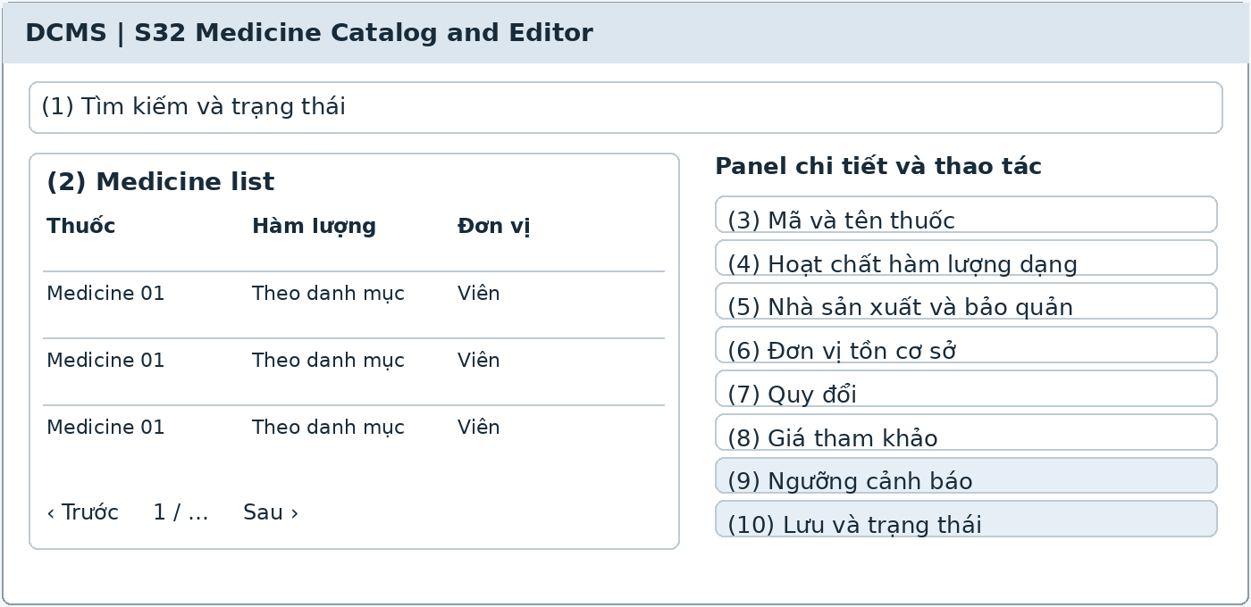
Illustrative UI layout Numbers in the image correspond to the field table on the next page
Functional Description and Use Cases
Medicine list and a panel for updating definitions, packaging, conversions, reference prices, and alert thresholds. UC-27 is named View Medicine Catalog in the catalog; edit permissions derive from MD-18 without assigning a new UC code.
Roles: Clinic Assistant.
Mapping: UC-27; updates are a business function in MD-18. References: MD-01, MD-06, MD-10, MD-17–MD-18.
Rules and Outcomes
• Medicines with different strengths or dosage forms are not merged merely because their names match.
• Expiry is stored per inventory batch; Medicine has no single shared expiry date.
• Packaging or price changes do not alter receipt, dispensing, or bill history.

Field Description S32
Medicine Catalog and Editor | 16.1.1
Field Name | Description
Catalog
(1) Search and status | String of 0–100 characters [PROPOSED]; search code, name, or active ingredient; Active/Inactive, default Active [PROPOSED].
(2) Medicine list | Code, name, active ingredient, strength, form, and stock unit; opens the medicine panel; do not display stock totals as part of the medicine definition.
(3) Medicine code and name | Unique code; name of 1–200 characters [PROPOSED]; required; do not use the name as the inventory movement key.
(4) Active ingredient strength and form | Strings of up to 200 characters per item [PROPOSED]; according to label and definition; do not automatically substitute similar medicines.
Units Prices and Alerts
(5) Manufacturer and storage | Manufacturer up to 200 characters, storage instructions up to 2,000 characters [PROPOSED]; no shared expiry for all batches.
(6) Base stock unit | Tablet, ampoule, bottle, or finalized whole unit; required. Multidose bottles need further assessment and must not be assumed supported.
(7) Conversion | Factor greater than 0 from receipt or dispensing unit to stock unit; must produce a whole quantity appropriate to the base-unit scope; transactions retain the factor at recording time.
(8) Reference price | Nonnegative VND per unit; suggests prices for new transactions without overwriting charged prices.
(9) Alert thresholds | Nonnegative minimum stock level; near-expiry day range from clinic configuration; do not automatically send push to Patients.
(10) Save and status | Clinic Assistant button; Active/Inactive [PROPOSED]; retain the prior version and do not delete medicines with receipt/issue history.

The common conventions for permissions, input data, error states, pagination, and concurrent operations also apply. [PROPOSED] identifies a limit or design choice requiring confirmation; it does not replace business rules in the source.

17 Medicine Inventory

17.1 Stock Visibility

17.1.1 Stock and Batch Overview
Screen ID S33 | Staff web
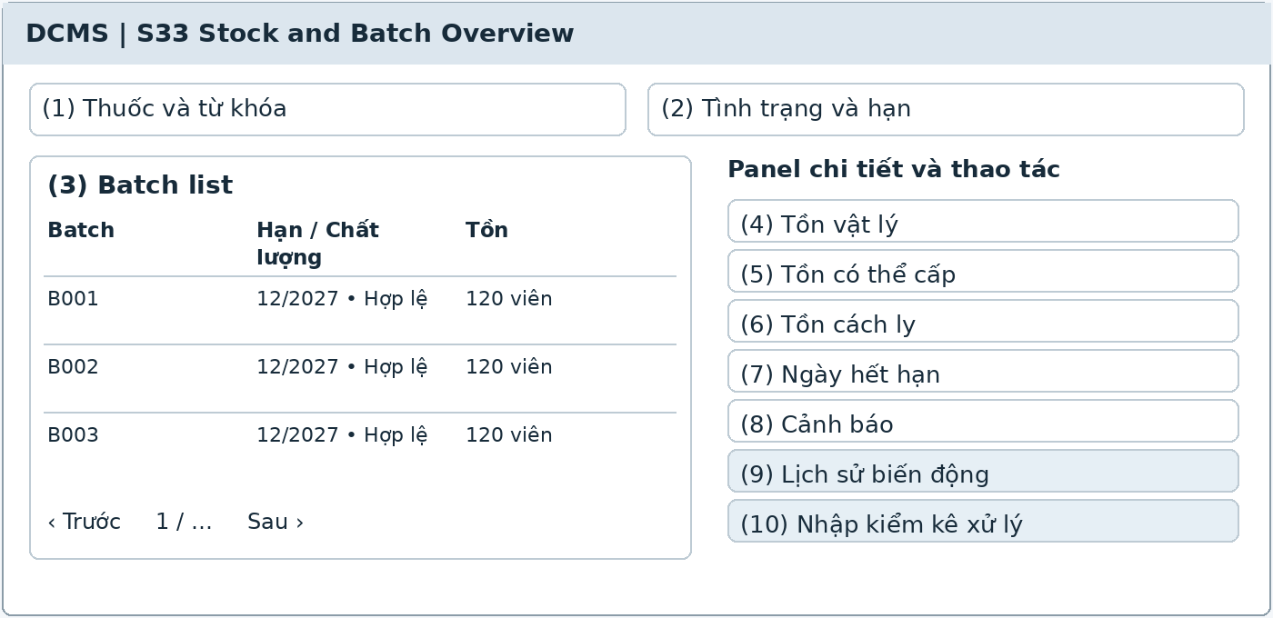
Illustrative UI layout Numbers in the image correspond to the field table on the next page
Functional Description and Use Cases
Displays stock by Medicine and Batch, separating physical, dispensable, and quarantined stock. Provides movement history and near-expiry, expiry, and low-stock alerts.
Roles: Clinic Assistant.
Mapping: Related to UC-27; no separate UC for stock overview. References: MD-02, MD-04–MD-06, MD-12–MD-13.
Rules and Outcomes
• FEFO suggests only eligible batches; expired, quarantined, or recalled batches are blocked from dispensing.
• Expiry does not automatically reduce physical stock; only actual return or disposal records a reduction.
• Inventory quantity and value are presented separately; do not promise a cost-of-goods method that has not been finalized.

Field Description S33
Stock and Batch Overview | 17.1.1
Field Name | Description
Medicine and Batch Filters
(1) Medicine and keyword | Select a Medicine or a string of 0–100 characters [PROPOSED]; defaults to all authorized inventory.
(2) Condition and expiry | Filter eligible, quarantined, recalled, expired, or near-expiry; quality condition and expiry flags are displayed separately [PROPOSED].
(3) Batch list | Internal batch code, label batch number, medicine, expiry, and condition; batch numbers always remain in Medicine context.
Stock and Actions
(4) Physical stock | Nonnegative integer in stock units; remaining quantity in the inventory ledger, including quarantine; not automatically equal to dispensable stock.
(5) Dispensable stock | Nonnegative integer calculated from remaining quantity, quality, and expiry on the clinic date; expired batches cannot be dispensed.
(6) Quarantined stock | Nonnegative integer; moving stock to quarantine does not increase or decrease total physical stock.
(7) Expiry date | Store according to the label and confirmed rules; if month/year rules are undefined, block classification as eligible for dispensing.
(8) Alerts | Near-expiry according to the configured day range, expired, or below minimum stock; alerts do not become stock issue documents.
(9) Movement history | Read-only receipt, dispense, treatment use, return, adjustment, and disposition with actor, time, and batch.
(10) Receive count or handle | Buttons leading to S34, S35, or S36 according to permissions; stock totals cannot be edited directly.

The common conventions for permissions, input data, error states, pagination, and concurrent operations also apply. [PROPOSED] identifies a limit or design choice requiring confirmation; it does not replace business rules in the source.

17.2 Receiving

17.2.1 Medicine Receipt
Screen ID S34 | Staff web
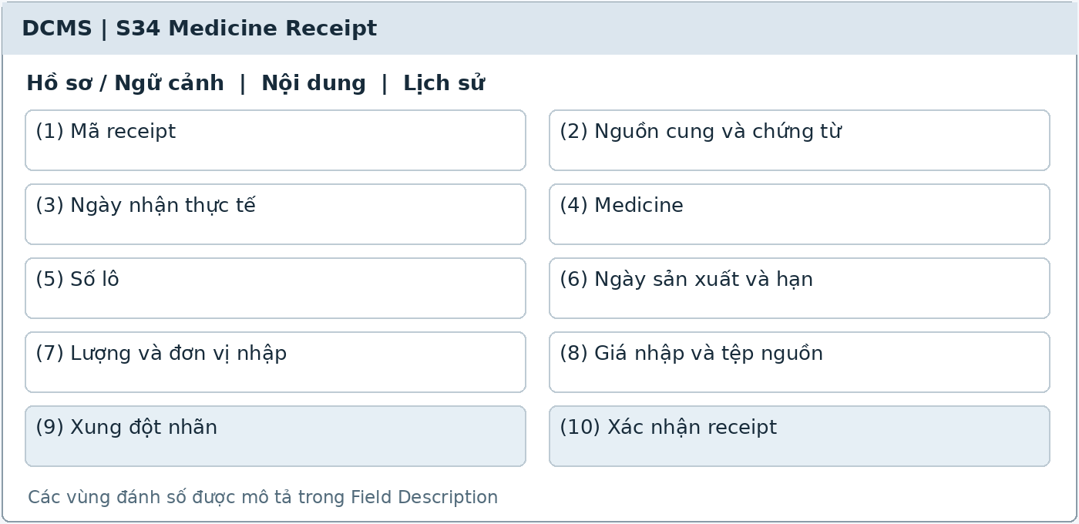
Illustrative UI layout Numbers in the image correspond to the field table on the next page
Functional Description and Use Cases
Create medicine receipt documents with source, supporting document, receipt date, medicine lines, batch numbers, expiry, and converted quantities. Multiple receipts for the same batch remain separate receipts.
Roles: Clinic Assistant.
Mapping: UC-28. References: MD-02–MD-03, MD-10, MD-18.
Rules and Outcomes
• Conflicting batch numbers or expiry dates must be checked before use is allowed.
• Only confirmed receipts increase batch stock; in-progress entries are not available for dispensing [PROPOSED].
• Confirmed documents retain history; errors are corrected through movements with reasons.

Field Description S34
Medicine Receipt | 17.2.1
Field Name | Description
Stock Receipt Document
(1) Receipt code | System-generated code, read-only after creation; a draft ID [PROPOSED] must not be used as a confirmed document.
(2) Supply source and document | Source up to 200 characters; document number up to 100 characters [PROPOSED]; retain the source file if available.
(3) Actual receipt date | Required datetime; defaults to now. Retrospective entries store actual and entry times separately and check documents for duplicates.
Medicine Lines and Batches
(4) Medicine | Active medicine code; required; show strength, form, and stock unit for comparison.
(5) Batch number | String of 1–100 characters [PROPOSED] from the label; required; look up within the correct Medicine, not by batch number alone.
(6) Manufacture date and expiry | Manufacture date optional; expiry required according to label. Store day or month/year precision and the approved determination rule.
(7) Quantity and receipt unit | Greater than 0; unit selected from packaging options; factor greater than 0; quantity converted to stock units must be whole and valid.
(8) Purchase price and source file | Nonnegative VND purchase price if available; files follow S20 limits; do not automatically use it as the selling price.
(9) Label conflict | Warn if batch numbers or expiry do not match existing data; require checking rather than automatically editing historical expiry.
(10) Confirm receipt | Button according to permissions; retain conversion snapshot, actor, time, and batch; resubmitting the same operation must not increase stock twice [PROPOSED].

The common conventions for permissions, input data, error states, pagination, and concurrent operations also apply. [PROPOSED] identifies a limit or design choice requiring confirmation; it does not replace business rules in the source.

17.3 Counting and Corrections

17.3.1 Stock Count and Adjustment
Screen ID S35 | Staff web
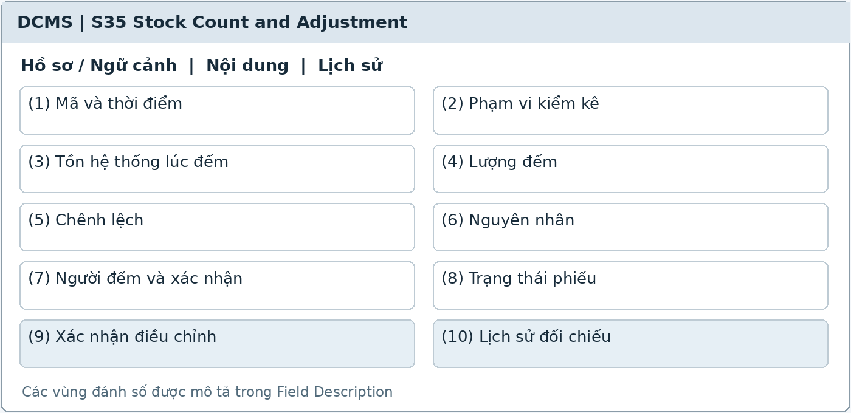
Illustrative UI layout Numbers in the image correspond to the field table on the next page
Functional Description and Use Cases
Record batch stock counts, compare system and counted quantities, and confirm adjustment movements with reasons. Retain both the counter and confirmer according to permissions.
Roles: Clinic Assistant authorized to confirm.
Mapping: UC-29. References: MD-04, MD-11, MD-18.
Rules and Outcomes
• Do not directly edit confirmed receipts or stock issues.
• Differences are checked against the count snapshot; concurrent changes require reconciliation again.
• Report access does not grant stock-change approval; do not automatically introduce a separate inventory role.

Field Description S35
Stock Count and Adjustment | 17.3.1
Field Name | Description
Stock Count Document
(1) Code and time | System-generated code; actual count time and entry time; count time required, default now.
(2) Count scope | Select a Medicine or batch list within one inventory; count dispensable and quarantined stock in their correct groups.
(3) System stock at count time | Read-only snapshot by batch and group; retain a version or movement reconciliation cutoff; do not silently replace it with current totals.
Count and Adjustment
(4) Counted quantity | Nonnegative integer in stock units; required for each confirmed row; initially unentered, not zero by default.
(5) Difference | Counted quantity minus system quantity; read-only; may be negative or positive and cannot be edited.
(6) Cause | String of 1–1,000 characters [PROPOSED]; required for nonzero differences; explanation required by batch.
(7) Counter and confirmer | Retrieved from the session; confirmer must be authorized; may be the same Clinic Assistant according to permissions, without mandatory multilevel approval.
(8) Document status | In progress or Confirmed [PROPOSED]; confirmed documents cannot be overwritten.
(9) Confirm adjustment | Button; validate nonnegative stock and latest data; create a batch movement linked to the document without replacing old history.
(10) Reconciliation history | Read-only before/after quantities, actor, time, reason, and document; corrections use approved supplementary records.

The common conventions for permissions, input data, error states, pagination, and concurrent operations also apply. [PROPOSED] identifies a limit or design choice requiring confirmation; it does not replace business rules in the source.

17.4 Quality and Batch Disposition

17.4.1 Quality Issue and Batch Disposition
Screen ID S36 | Staff web
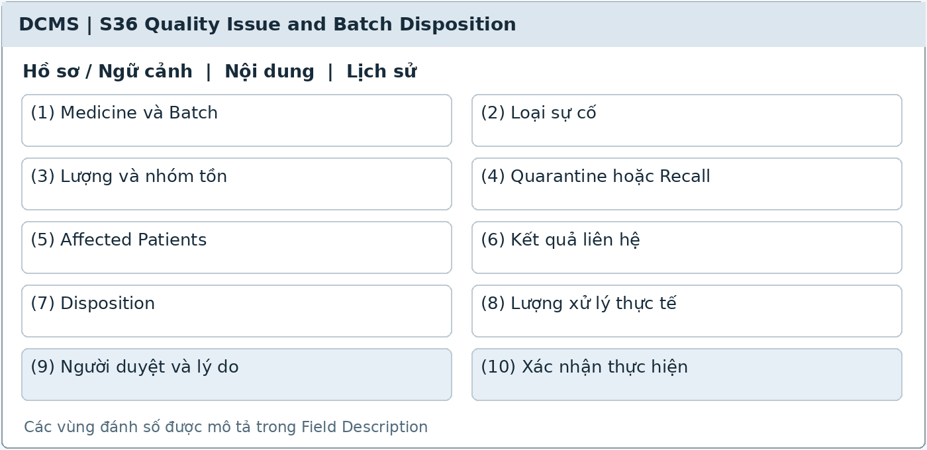
Illustrative UI layout Numbers in the image correspond to the field table on the next page
Functional Description and Use Cases
Record quality incidents, quarantine or recall batches, trace medicine recipients, and handle release, return to supplier, or actual disposal according to approval.
Roles: Clinic Assistant according to handling and confirmation permissions.
Mapping: MD-12–MD-15 functions; related to UC-27, UC-29, UC-25; no separate UC. References: MD-12–MD-15, MD-18.
Rules and Outcomes
• Quarantine or recall immediately blocks dispensing while retaining physical stock.
• Medicines returned by Patients enter quarantine; release requires assessment and approval.
• Expired batches cannot be released for dispensing; physical reductions are recorded only after return or disposal is performed.

Field Description S36
Quality Issue and Batch Disposition | 17.4.1
Field Name | Description
Incident and Batch
(1) Medicine and Batch | Required; code, label batch number, expiry, and current stock are read-only; do not select a batch of another Medicine.
(2) Incident type | Expired, Damaged, Suspected quality issue, or Recall [PROPOSED]; reason of 1–1,000 characters and evidence if available.
(3) Quantity and stock group | Integer greater than 0 for affected quantity; must not exceed the remaining source-group quantity; the entire batch may be blocked even when stock is low.
(4) Quarantine or Recall | Button confirming a dispensing block; group transfers do not change total physical stock; record actor, time, and basis.
Traceability and Disposition
(5) Affected Patients | List of related dispensing/use events, Patients, batches, quantities, and times; staff view only within handling permissions; no public export.
(6) Contact result | Call status, recall results, and Patient return documents; do not automatically edit Bill or Payment.
(7) Disposition | Release, Return to supplier, or Dispose; only options consistent with quality, expiry, and approved processes.
(8) Actual handled quantity | Integer greater than 0, not exceeding source-group stock; performance date required before recording a physical reduction.
(9) Approver and reason | Authorized person, approval time, reason, and supporting documents; Admins are not assumed to have inventory permissions.
(10) Confirm performance | Button; retain movements and incident links; check the latest batch and prevent duplicate documents on resubmission [PROPOSED].

The common conventions for permissions, input data, error states, pagination, and concurrent operations also apply. [PROPOSED] identifies a limit or design choice requiring confirmation; it does not replace business rules in the source.

18 Medicine Dispensing

18.1 Actual Medicine Movements

18.1.1 Medicine Dispensing Treatment Use and Return
Screen ID S37 | Staff web
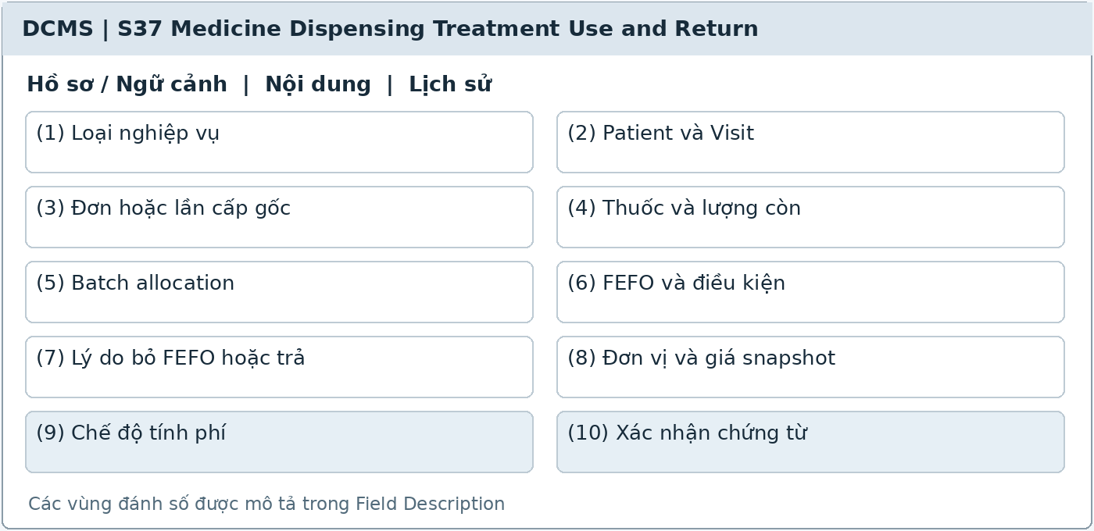
Illustrative UI layout Numbers in the image correspond to the field table on the next page
Functional Description and Use Cases
Record medicines actually dispensed, used in treatment, or returned by Patients, by batch and source document. Permissions apply per tab: Dentists record actual use only, without dispensing or receiving returns.
Roles: Clinic Assistant dispenses and receives returns; Dentist or Clinic Assistant records actual use according to permissions.
Mapping: UC-22, UC-18; receiving returns under MD-14. References: MD-05, MD-07–MD-10, MD-14, MD-16–MD-18.
Rules and Outcomes
• FEFO selects eligible batches only; overriding the suggestion requires a reason and cannot bypass expiry/quality blocks.
• Recheck on confirmation to prevent negative stock or dispensing above the prescription's remaining quantity; retries must not issue stock or charge twice.
• Patient returns reference the original dispensing and cannot exceed the returnable remainder; always enter quarantine and do not automatically adjust finances.

Field Description S37
Medicine Dispensing Treatment Use and Return | 18.1.1
Field Name | Description
Context and Source
(1) Operation type | Dispense, Treatment use, or Patient return; show tabs only according to role; no independent retail medicine sales process.
(2) Patient and Visit | Required according to the operation; the correct actual recipient or treated person; verified context is read-only.
(3) Prescription or original dispensing | Dispense selects a completed prescription and medicine line; Return selects the original dispensing; Treatment use links to a Visit activity.
(4) Medicine and remaining quantity | Medicine code, strength, form, and unit; read-only remaining prescribed quantity eligible for dispensing or remaining returnable quantity from the source; do not calculate by medicine name.
Batches and Confirmation
(5) Batch allocation | List of batches and actual quantities; multiple batches or partial dispensing allowed; each quantity is an integer greater than 0 in stock units.
(6) FEFO and eligibility | Suggest the nearest-expiry eligible batch; check expiry against the clinic date and quality at confirmation, not merely alerts.
(7) Reason for overriding FEFO or returning | Required for overriding suggestions or Patient returns; string of 1–1,000 characters [PROPOSED]; does not bypass ineligible-batch blocks.
(8) Unit and price snapshot | Retain the conversion factor, unit, and actual charged price at dispensing/use; catalog price changes do not change old transactions.
(9) Charging mode | Included in service/package price, Charged separately, or Free; only chargeable quantities actually dispensed/used become sources for S38.
(10) Confirm document | Atomically validate stock and source quantities; returns enter quarantine, dispensing/use reduces stock; store actor, time, batch, and duplicate-submission prevention key.

The common conventions for permissions, input data, error states, pagination, and concurrent operations also apply. [PROPOSED] identifies a limit or design choice requiring confirmation; it does not replace business rules in the source.

19 Billing

19.1 Itemized Bills

19.1.1 Patient Bill
Screen ID S38 | Staff web
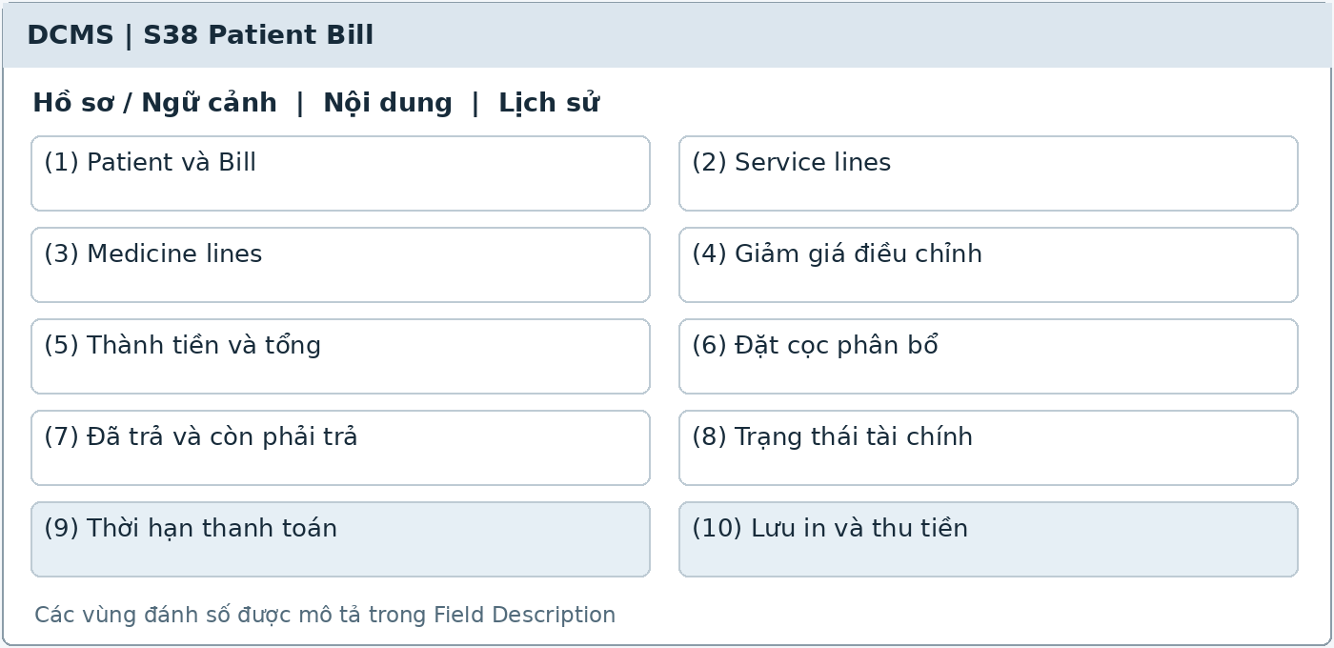
Illustrative UI layout Numbers in the image correspond to the field table on the next page
Functional Description and Use Cases
Create itemized bills from performed services and chargeable medicines actually dispensed or used, retaining agreed prices and authorized adjustments. Do not include proposed services or merely prescribed medicines in receivables.
Roles: Clinic Assistant.
Mapping: UC-19. References: FN-03–FN-05, FN-08–FN-15, TR-10, MD-17.
Rules and Outcomes
• Medicines included in packages or provided free have no separate medicine charge; do not duplicate charges from the same source.
• Allocate deposits once and show paid and remaining amounts.
• Patient returns do not automatically reduce Bills; visit completion does not require a PAID Bill.

Field Description S38
Patient Bill | 19.1.1
Field Name | Description
Invoice and Charge Lines
(1) Patient and Bill | Verified Patient; system-generated BillId is read-only; link Visit, Plan, or charging sources according to finalized billing rules.
(2) Service lines | TreatmentActivity source, service, quantity, unit, and agreed price; do not charge the entire unperformed plan.
(3) Medicine lines | Source documents for chargeable actual dispensing/use; issue event code, quantity, and price snapshot; do not link solely by name or prescription.
(4) Discounts and adjustments | Nonnegative values according to permissions; reason of 1–500 characters [PROPOSED]; line amounts must not become negative in the base design [PROPOSED].
(5) Line amounts and total | Read-only quantity × unit price minus valid discounts; VND under the conventions; retain finalized rounding rules.
Balance and Tracking
(6) Allocated deposits | Nonnegative amount, not exceeding unused deposits or the amount due; reference the source and do not count deposits again as new cash received.
(7) Paid and outstanding amounts | Read-only from valid payments and allocations; total money received cannot be manually edited.
(8) Financial status | Unpaid, Partially paid, or Paid [PROPOSED]; Paid only when fully paid; status does not determine Visit status.
(9) Payment deadline | Optional when agreed; distinguish not yet due, due, and overdue; do not require every Bill to have an installment schedule.
(10) Save print and collect payment | Buttons to save according to permissions, print, or export the bill; go to S39 to receive and record payments; saving a Bill does not reduce stock.

The common conventions for permissions, input data, error states, pagination, and concurrent operations also apply. [PROPOSED] identifies a limit or design choice requiring confirmation; it does not replace business rules in the source.

20 Payment

20.1 Receipts and Payment Corrections

20.1.1 Payment and Receipt
Screen ID S39 | Staff web
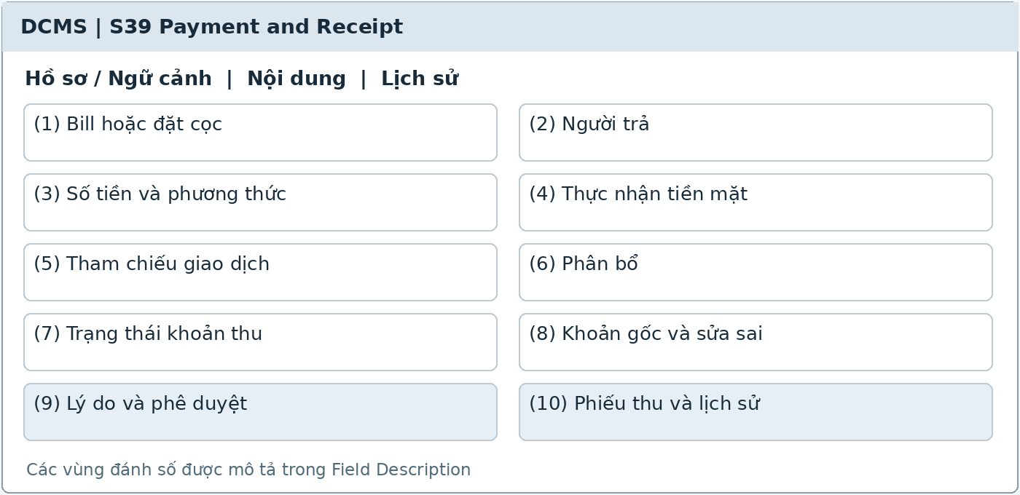
Illustrative UI layout Numbers in the image correspond to the field table on the next page
Functional Description and Use Cases
Record deposits, payments, allocations, and receipts. Cash is confirmed as actually received by the assistant; electronic transactions are recorded once after authentication or retained pending reconciliation. Payment recording corrections require evidence and are not refunds.
Roles: Clinic Assistant records and corrects payments; Patient pays; Payment Gateway when integrated.
Mapping: UC-20, UC-21, UC-23. References: FN-05–FN-09, FN-12–FN-13, section 14.
Rules and Outcomes
• Do not delete confirmed payments; corrections link the original payment, reason, and approval according to permissions.
• SUCCESS confirms a transaction; Paid applies only when the Bill is fully paid; unmatched payments do not automatically settle the Bill.
• Payment does not reduce stock or complete visits; there are no refund requests, approvals, or execution.

Field Description S39
Payment and Receipt | 20.1.1
Field Name | Description
Collection and Allocation
(1) Bill or deposit | Bill code for invoice payments; deposits retain the source Patient and purpose; a booking is not automatically evidence of medical record access.
(2) Payer | Patient or third-party payer; name and contact channel as needed for the receipt; paying for someone else does not open the Patient's own records.
(3) Amount and method | VND greater than 0; Cash, Transfer/QR, or Gateway according to integration; two methods are recorded as two separate payments.
(4) Cash actually received | Clinic Assistant button confirming actual cash received; record actor and time; do not simulate a cash webhook.
(5) Transaction reference | Request code, provider code, amount, currency, and status; no card authentication details; authenticate callbacks on the server.
(6) Allocation | List of amounts allocated to Bills; do not exceed available payment or amount due; retain unused deposits separately without creating a second payment received.
Reconciliation and Receipts
(7) Payment record status | Confirmed or Awaiting reconciliation; provider status shown separately using actual returned values; a single SUCCESS callback does not automatically make a Bill Paid.
(8) Original payment and correction | Select a confirmed payment; record the correct amount and supporting basis for the difference [PROPOSED]. Do not record outgoing transfers to Patients or create refund transactions.
(9) Reason and approval | String of 1–1,000 characters [PROPOSED]; required for corrections; retain authorized approver, time, and original record reference; the detailed process requires confirmation.
(10) Receipts and history | Receipt code, actual payment, method, allocation, and time; view, print, or export; corrections retain both history and recalculated balances.

The common conventions for permissions, input data, error states, pagination, and concurrent operations also apply. [PROPOSED] identifies a limit or design choice requiring confirmation; it does not replace business rules in the source.

21 Reporting

21.1 Clinic Reports

21.1.1 Reports Dashboard and Viewer
Screen ID S40 | Staff web
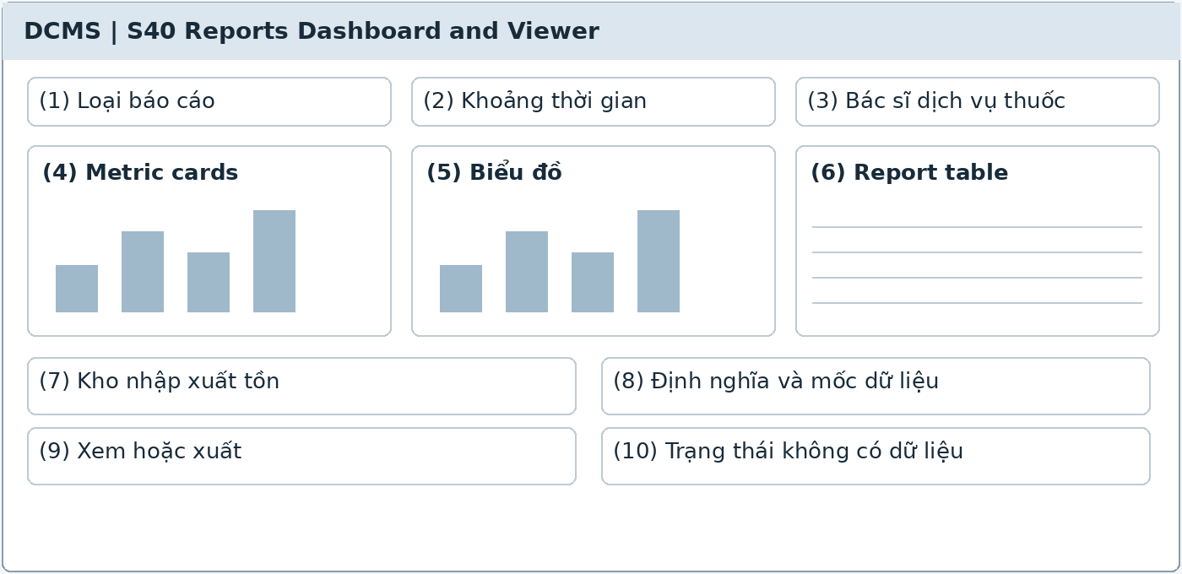
Illustrative UI layout Numbers in the image correspond to the field table on the next page
Functional Description and Use Cases
Dashboard and detail tables within permission scope, covering operations, actual receipts, receivables, treatment, follow-up, and medicine inventory. Clearly present metric definitions and data timestamps.
Roles: Admin; Clinic Owner.
Mapping: UC-32. References: Section 9, MD-18, FN-09–FN-10, section 15.
Rules and Outcomes
• Admins and Clinic Owners read reports only; reports do not grant clinical, financial, or inventory editing permissions.
• Do not combine actual payments received with the value of performed services or used/dispensed medicines into an undefined revenue figure.
• Inventory quantity and value are separate; cost of goods is available only after a method is defined.

Field Description S40
Reports Dashboard and Viewer | 21.1.1
Field Name | Description
Report Scope
(1) Report type | Operations, Actual receipts, Receivables, Treatment, Follow-up, or Medicine inventory; list according to permissions.
(2) Time range | Start date must not follow end date; defaults to the current month [PROPOSED]; clinic time zone; stock reports require a cutoff timestamp.
(3) Dentist service and medicine | Filters according to report type; show only authorized values; filters do not expand read access.
Metrics and Data
(4) Metric cards | Appointment count, visit count, new Patients, actual receipts, or receivables according to report; clear units and definitions.
(5) Charts | By day, dentist, method, or suitable group; do not mix VND with visit counts or medicine quantities on the same unexplained scale.
(6) Report table | Record details and totals; restrict identifying information according to report scope; drilldown must not expose unauthorized data.
(7) Inventory receipts issues and balances | Opening stock, receipts, dispensing/use, returns, adjustments/dispositions, and closing stock by Medicine, Batch, and unit; separate dispensable and quarantined stock.
(8) Definitions and data cutoff | Last update, metric formulas, and missing data; do not report zero when a report fails to load.
(9) View or export | Read-only buttons; export according to permissions and the filtered period; no buttons to edit Patient, Payment, or Batch.
(10) No-data state | Explain an empty period or lack of viewing permission; source errors are shown separately from zero data.

The common conventions for permissions, input data, error states, pagination, and concurrent operations also apply. [PROPOSED] identifies a limit or design choice requiring confirmation; it does not replace business rules in the source.

22 Background Job Inventory
The tasks below do not create Screen IDs. Technical schedules are proposals requiring configuration; finalized business thresholds remain enforced on the server. Each task has logs, error states, and appropriate duplicate-processing prevention keys; this table adds no approval functions outside the scope.

BG-01 No-show detection
Attribute | Specification
Trigger and Schedule | Scan Confirmed appointments not checked in 15 minutes after the start time. Scan interval ≤ 1 minute [PROPOSED]; the business threshold is 15 minutes.
Processing and Safeguards | Check the latest status using conditional updates; do not overwrite Checked-in/Completed/Cancelled. Create one callback task; still-valid instructions return to Needs booking. Record the reason Patient did not attend.
References and Screens | AP-16–AP-17, FU-03; S17, S25

BG-02 Reminder planning
Attribute | Specification
Trigger and Schedule | Triggered by booking/rescheduling/cancellation events and instruction creation/editing/cancellation. Plan timings from clinic configuration; do not default to 24 hours.
Processing and Safeguards | Cancel the old version's send schedule and recreate it if still needed. Booking reminders follow appointment times; follow-up reminders follow deadlines without bookings. Do not send reminders for elapsed appointments.
References and Screens | NT-01–NT-03; S12, S24, S26

BG-03 Due follow-up processing
Attribute | Specification
Trigger and Schedule | At the reminder time for an unbooked or overdue instruction; checking interval follows configuration.
Processing and Safeguards | Retain Needs booking; send authorized notifications and create staff contact tasks, including for people without the app. Overdue is a flag computed from the end date and does not automatically mean Completed.
References and Screens | FU-04–FU-05; S25

BG-04 Notification delivery and retry
Attribute | Specification
Trigger and Schedule | Process due notifications and still-permitted retries. Attempt counts, backoff, and send deadlines require confirmation.
Processing and Safeguards | Check version, object status, active account, link, and preferences. Retain each attempt; final failures/no channel go to S28. Provider accepted does not mean read.
References and Screens | NT-03–NT-06; S26–S28

BG-05 Inventory alerts
Attribute | Specification
Trigger and Schedule | After stock movements and a local-date scan [PROPOSED]; use configured minimum levels and near-expiry day ranges.
Processing and Safeguards | Update low-stock/near-expiry/expiry alerts in S33. Do not reduce stock because of expiry or create Patient push. Dispensing must still check expiry at confirmation.
References and Screens | MD-04–MD-06, MD-12; S33

BG-06 Imaging AI processing
Attribute | Specification
Trigger and Schedule | After the dentist explicitly requests analysis of a valid image; asynchronous processing according to module configuration.
Processing and Safeguards | Retain request ID, image, Patient/Visit, model version, and results. Reject mismatched or erroneous result links; late results must not be written to a different Visit. The dentist may still complete manually.
References and Screens | XR-AI-01–XR-AI-06; S19

BG-07 Payment reconciliation
Attribute | Specification
Trigger and Schedule | When a callback is unmatched, results are missing, or under a finalized reconciliation schedule; only with Gateway integration.
Processing and Safeguards | Authenticate and match Bill/request, amount, VND, and transaction ID. Record one payment; retain Awaiting reconciliation when evidence is insufficient. Recalculate balances without reducing stock or refunding.
References and Screens | FN-06, section 14; S39, S42

BG-08 Backup and recovery check
Attribute | Specification
Trigger and Schedule | According to backup schedules and recovery targets requiring confirmation in operating requirements.
Processing and Safeguards | Back up data and documents with permission controls; retain results and report operational errors. Test recovery under an approved schedule [PROPOSED]; backups do not grant medical record access.
References and Screens | Section 10; operational function

Conversation retention and deletion policies are not finalized; no automatic deletion task is included in the operating inventory. Slots are generated from weekly schedules and availability conditions; do not assume a job automatically deletes or changes confirmed bookings.

23 External API Inventory
This inventory describes required integration contracts, not selected endpoints or providers. Only external adapters belong in this section; the app/web backend and internal Imaging AI module are not counted as external actors. There is no refund API, automatic Zalo/Facebook integration, or API exporting full medical records to the chatbot.

API-01 Contact verification service
Attribute | Specification
Integration Scope | Conditional when using an external email/SMS service; provider and channels have not been selected.
Outbound and Inbound Data | DCMS sends contact verification or recovery requests with minimal address and correlation ID data. The provider returns send status; code/token format and verification processes require confirmation.
Authentication Errors and Retries | Successful sending does not mean verified. Tokens expire and are single-use; do not log secrets; retry under rate limits. Contact verification does not automatically grant Verified self-record status.
References and Screens | UC-02, UC-33; S02, S03

API-02 Push service
Attribute | Specification
Integration Scope | Push notification integration with the selected provider; applies when a valid account and device exist.
Outbound and Inbound Data | Send device token, general content, and a safe deep link; receive provider message ID, accepted/rejected, and error codes. Status callbacks if supported by the provider.
Authentication Errors and Retries | Do not send diagnoses/prescriptions. Check permissions before sending and opening links. Read status is confirmed by the app, not inferred from the provider. Final failures trigger staff follow-up without cancelling bookings.
References and Screens | UC-34, UC-24; NT-01–NT-06; S26–S28

API-03 Conversational AI service
Attribute | Specification
Integration Scope | External AI/LLM system for the chatbot; the chatbot orchestration module resides within DCMS.
Outbound and Inbound Data | Send questions and minimal authorized context from approved information. Receive responses, processing status, and required metadata. Actual slots/prices come from DCMS, not model text.
Authentication Errors and Retries | Do not send X-ray images or full medical records; do not diagnose/prescribe. Timeout/error leads to forms or handoff. Booking actions occur only after user confirmation and backend validation.
References and Screens | UC-35; AI-01–AI-06; S29, S30

API-04 Payment request and status
Attribute | Specification
Integration Scope | Conditional Payment Gateway; API parameters, sandbox, signatures, and channels require confirmation.
Outbound and Inbound Data | Send Bill/request ID, VND amount, and minimal payer reference. Receive request/transaction ID, QR or redirect, expiry, and status. Status queries support checking or reconciliation if the provider supports them.
Authentication Errors and Retries | Do not collect secret card data in DCMS forms when using a hosted flow [PROPOSED]. Reuse the same request key for retries; timeouts retain an uncertain status rather than collecting again or automatically reporting Paid.
References and Screens | UC-20; FN-06, section 14; S39, S42

API-05 Payment result webhook
Attribute | Specification
Integration Scope | Inbound from the Payment Gateway when integrated; the specific endpoint and authentication mechanism have not been selected.
Outbound and Inbound Data | Receive event/transaction ID, request or Bill, amount, currency, status, and authentication evidence. DCMS returns acknowledgment under the provider contract.
Authentication Errors and Retries | Authenticate signatures/notifications; prevent replay and duplicate transactions; match codes/amount/VND. SUCCESS records a payment only once; Paid requires full payment; mismatches remain awaiting reconciliation. Do not reduce stock or perform refunds.
References and Screens | UC-20; section 14; BG-07; S39, S42

API-06 X-ray or PACS order and image exchange
Attribute | Specification
Integration Scope | Conditional when the equipment or PACS supports direct communication; DICOM/DICOMweb protocols or specific adapters require assessment.
Outbound and Inbound Data | Send minimal identity details, Patient/Visit codes, orders, and imaging regions. Receive images or DICOM, metadata, imaging status, and correlation ID. Without integration, use manual upload in S20.
Authentication Errors and Retries | Match the correct person and Visit before saving or analysis; identity conflicts require review rather than default linking. File access permissions and Patient-visible rules still apply; handle embedded identity information under the approved data-processing basis.
References and Screens | UC-10, UC-11, UC-12; EX-05–EX-07; S19, S20

Imaging AI is an internal DCMS module according to the source; no provider or model has been selected. BG-06 describes in-system orchestration. Only after an external-service deployment choice is confirmed should a separate external API contract be added, covering minimal images/metadata, request ID, model version, status, findings, applicability limits, and identity-handling procedures. Do not combine this contract with the Conversational AI Service.

